Lecture VIII
Histamine and Antihistaminic Agents
Histamine or β-imidazolylethylamine is synthesized from L-histidine by histidine decarboxylase, an enzyme that is expressed in many mammalian tissues including gastricmucosa parietal cells, mast cells, and basophils and the central nervous system (CNS).1 As a result, histamine plays an important role in human physiology including regulation of the cardiovascular system, smooth muscle, exocrine glands, the immune system, and central nerve function. It is also involved in embryonic development, the proliferation and differentiation of cells, hematopoiesis, inflammation, and wound healing. Histamine exerts its diverse biologic effects through four types of receptors. The involvement of histamine in the mediation of immune and hypersensitivity reactions and the regulation of gastric acid secretion has led to the development of important drug classes useful in the treatment of symptoms associated with allergic and gastric hypersecretory disorders.
Nomenclature Histamine, known trivially as 4(5-) (2-aminoethyl)imidazole, structurally is composed of an imidazole heterocycle and ethylamine side chain. The methylene groups of the aminoethyl side chain are designated and. The side chain is attached, via the -CH2 group, to the 4-position of an imidazole ring. The imidazole N at position 3 is designated the pros () N, whereas the N at position 1 is termed the tele () N. The side chain N is distinguished as N (Fig. 23.1). Ionization and Tautomerization Histamine is a basic organic compound (N, pKa1 5.80; N pKa2 9.40; N , pKa3 14.0) capable of existing as a mixture of different ionic and uncharged tautomeric species (Fig. 23.2).2,3 Histamine exists almost exclusively (96.6%) as the monocationic conjugate species (NH3 ) at physiological pH (7.4). At lower pHs, a higher percentage of the dicationic species exists. In water, the ratio of the concentrations of the tautomers N MH/NMH has been calculated to be 4.2, indicating that 80% of the histamine monocation exists as N MH and 20% exists as NMH in aqueous solution.2,3 However, crystalline forms of histamine salts appear to exist primarily as NMH tautomer to facilitate crystal packing. Also, for derivatives of histamine, the ratio of tautomers is dependent on the presence of imidazole ring substituents as discussed later in this chapter.4 Structure–activity relationship studies suggest that the NH3 monocation is important for agonist activity at histamine receptors and that transient existence of the more lipophilic uncharged histamine species may contribute to diffusion across cell membranes. Other studies support proposal that the N MH tautomer of the histamine monocation is the pharmacophoric species at the H₁-receptor, while a 1,3-tautomeric system is important for selective H₂-agonism.
Stereochemistry
While histamine is an achiral molecule, histamine receptors exert high stereoselectivity toward chiral ligands.5 Molecular modeling and steric–activity relationship studies of the influence of conformational isomerism suggest the importance of trans-gauche rotameric structures in the receptor binding of histamine (Fig. 23.3). Although both conformers exist in solution, studies with conformationally restricted histamine analogs suggest that the trans-rotamer of histamine possesses affinity for both H1- and H2-receptors, and the gauche conformer is preferred for H3-receptors, but not H1- or H2-receptors.
Knowledge of the biodisposition of histamine is important in understanding the involvement of this substance in various pathophysiologies as well as the actions of various ligands that either enhance or block its actions. Each of the steps in the “life cycle” of histamine represents a potential point for pharmacological intervention. Biosynthesis and Distribution Histamine is synthesized in Golgi apparatus of its principal storage cells, mast cells, and basophils.6 Histamine is formed from the naturally occurring amino acid L-hisitidne (S-histidine) via the catalysis of either the pyridoxal phosphate dependent enzyme histidine decarboxylase (HDC, EC 4.1.1.22) or L-aromatic amino acid decarboxylase (L-AAAD) (Fig. 23.4). Substrate specificity is higher for HDC versus L-AAAD. HDC inhibitors (HDCIs) include -fluoromethylhistidine (FMH), a mechanism-based inhibitor, and certain flavonoids.7 Although useful as pharmologic probes, HDCIs have not proved to be useful clinically.
Histamine is found in almost all mammalian tissues in concentrations ranging from 1 to more than 100 g/g. Mast cells and histamine are in particularly high concentration in skin and the mucosal cells of the bronchi, intestine, urinary tract, and tissues adjacent to the circulation. It is found in higher concentrations in mammalian cerebrospinal fluid than in plasma and other body fluids. Storage and Release Most histamine is biosynthesized and stored as protein complexes in mast cells (complexed with heparin) and basophilic granulocytes (complexed with chondroitin).8,9 Proteincomplexed histamine is stored in secretory granules and released by exocytosis in response to a wide variety of immune (antigen and antibody) and nonimmune (bacterial products, xenobiotics, physical effects, and cholinergic effects) stimuli. The release of histamine as one of the mediators of hypersensitivity reactions is initiated by the interaction of an antigen-IgE complex with the membrane of a histamine storage cell. This interaction triggers activation of intracellular phosphokinase C (PKC), leading to accumulation of inositol phosphates, diacylglycerol, and calcium. Exocytotic release of histamine follows the degranulation of histamine storage cells.10 Degranulation also results in the release of other mediators of inflammation including prostaglandins, leukotrienes, platelet-activating factor, kinins, etc.10 The release of mast cell mediators can be inhibited by several agents as described in the sections that follow. Histamine is released from mast cells in the gastric mucosa by gastrin and acetylcholine. Neurochemical studies also suggest that histamine is stored in and released from selected neuronal tracts in the CNS.
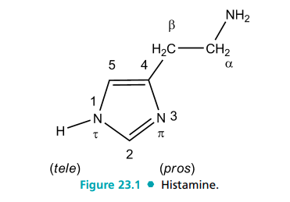
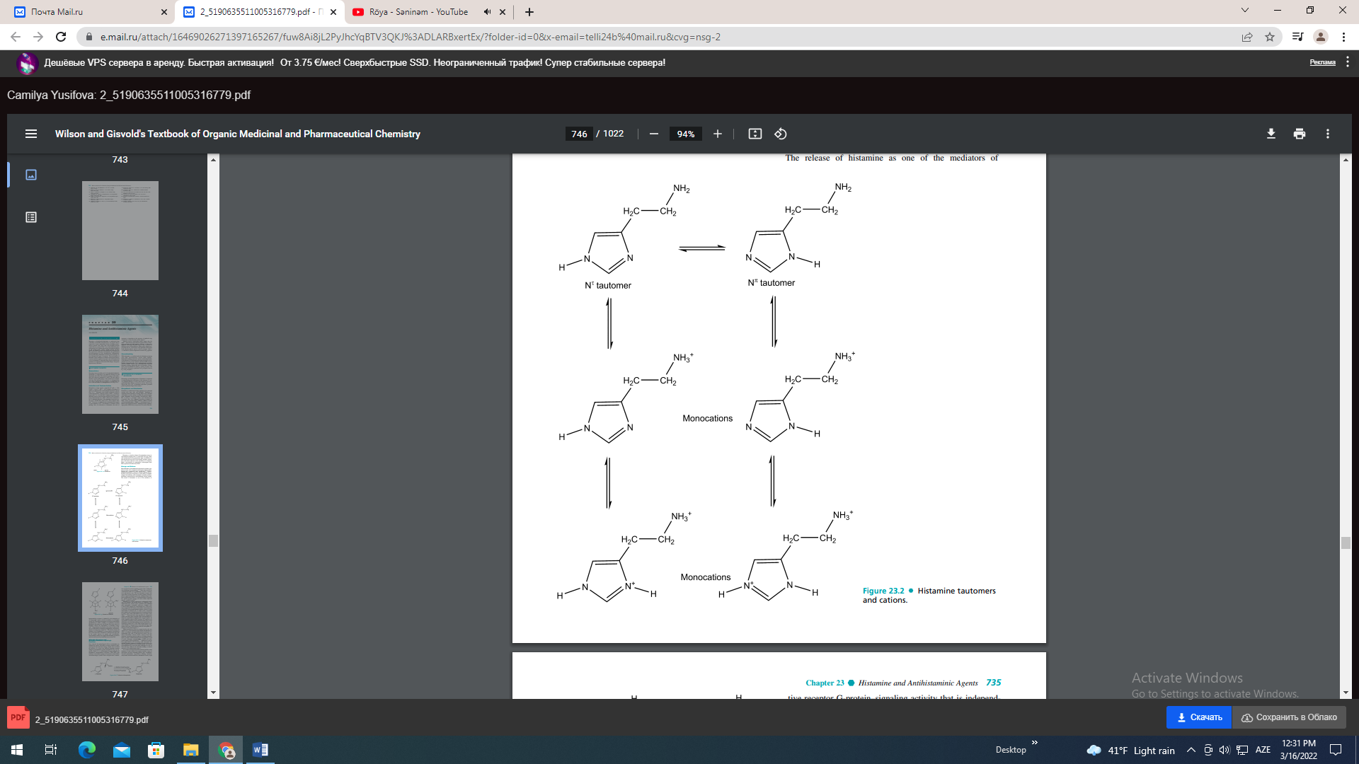
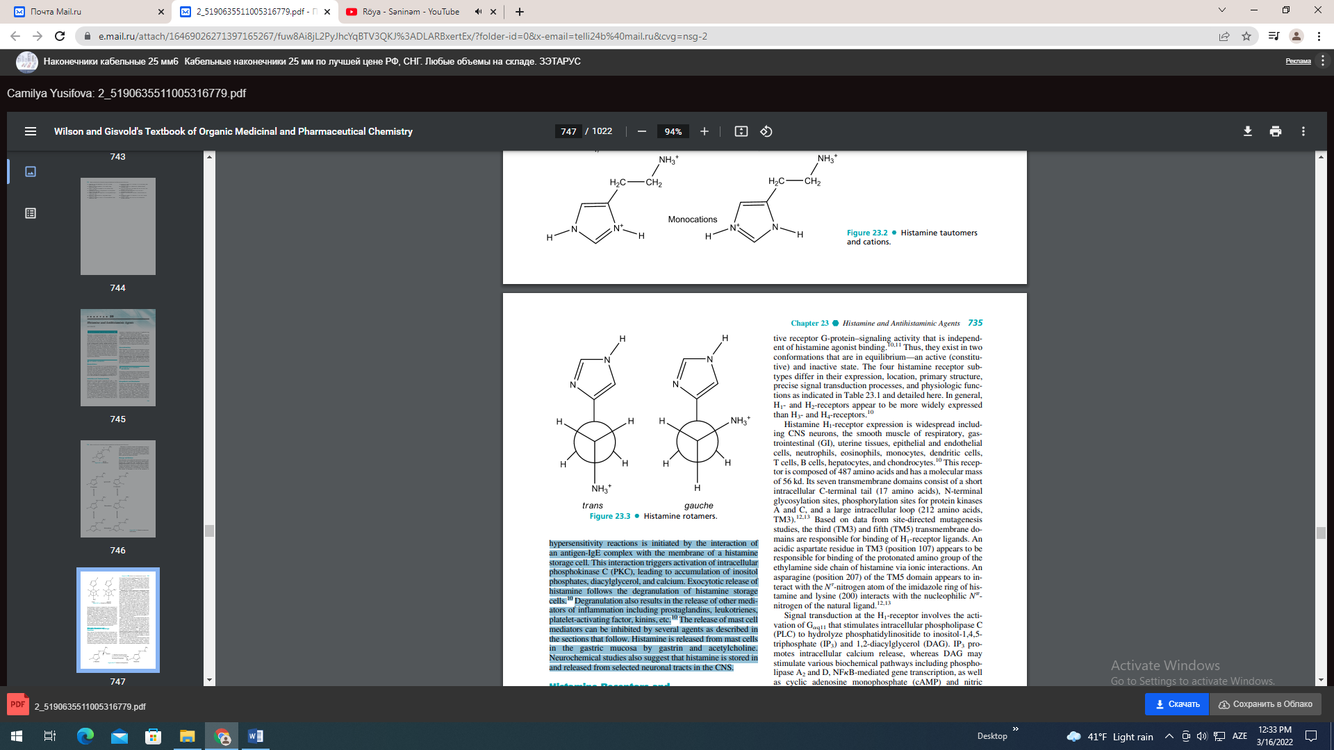
Histamine Receptors and Histamine-Mediated Physiologic Functions
Once released, the physiological effects of histamine are mediated by specific cell-surface receptors. Extensive pharmacological and molecular biology studies have revealed the presence of at least four different histamine receptor subtypes in mammalian systems designated as H1, H2, H3, and H4 (Table 23.1).10 All histamine receptor subtypes are heptahelical transmembrane molecules (TM1-TM7) that transduce extracellular signals via G-proteins to intracellular second-messenger systems. These receptors have constitutive receptor G-protein–signaling activity that is independent of histamine agonist binding.10,11 Thus, they exist in two conformations that are in equilibrium—an active (constitutive) and inactive state. The four histamine receptor subtypes differ in their expression, location, primary structure, precise signal transduction processes, and physiologic functions as indicated in Table 23.1 and detailed here. In general, H1- and H2-receptors appear to be more widely expressed than H3- and H4-receptors.10 Histamine H1-receptor expression is widespread including CNS neurons, the smooth muscle of respiratory, gastrointestinal (GI), uterine tissues, epithelial and endothelial cells, neutrophils, eosinophils, monocytes, dendritic cells, T cells, B cells, hepatocytes, and chondrocytes.10 This receptor is composed of 487 amino acids and has a molecular mass of 56 kd. Its seven transmembrane domains consist of a short intracellular C-terminal tail (17 amino acids), N-terminal glycosylation sites, phosphorylation sites for protein kinases A and C, and a large intracellular loop (212 amino acids, TM3).12,13 Based on data from site-directed mutagenesis studies, the third (TM3) and fifth (TM5) transmembrane domains are responsible for binding of H1-receptor ligands. An acidic aspartate residue in TM3 (position 107) appears to be responsible for binding of the protonated amino group of the ethylamine side chain of histamine via ionic interactions. An asparagine (position 207) of the TM5 domain appears to interact with the N -nitrogen atom of the imidazole ring of histamine and lysine (200) interacts with the nucleophilic N- nitrogen of the natural ligand.12,13 Signal transduction at the H1-receptor involves the activation of Gq11 that stimulates intracellular phospholipase C (PLC) to hydrolyze phosphatidylinositide to inositol-1,4,5- triphosphate (IP3) and 1,2-diacylglycerol (DAG). IP3 promotes intracellular calcium release, whereas DAG may stimulate various biochemical pathways including phospholipase A2 and D, NFB-mediated gene transcription, as well as cyclic adenosine monophosphate (cAMP) and nitric oxide synthase (NOS) production.10–13 Human H1-receptors have approximately 45% homology with muscarinic M1- and M2-receptors, perhaps accounting for some of the overlap in ligands bound by each receptor subtype. H1-receptor polymorphisms have been described, although it is not yet clear how they influence the histamine binding or clinical response to H1-antihistamine drugs.14 As a result of widespread tissue localization and the varied functions of these tissues, H1-receptors mediate a host of physiologic processes including pruritus, pain, vasodilation, vascular permeability, hypotension, flushing, headache, tachycardia, bronchoconstriction, stimulation of airway vagal afferent nerves and cough receptors, and decreased atrioventricular-node conduction time.
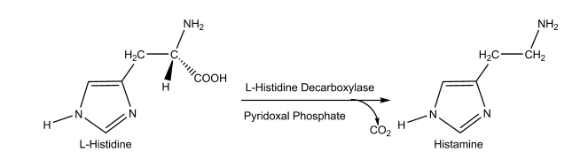

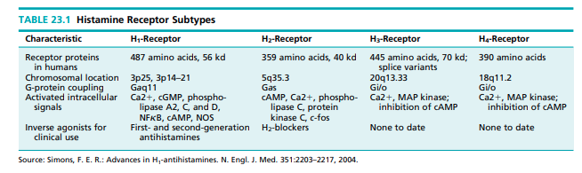
With respect to the cells involved in the immune response, released histamine acting at H1-receptors causes increased cellular adhesion–molecule expression and chemotaxis of eosinophils and neutrophils, increased antigen-presenting–cell capacity, costimulatory activity on B cells, blocking of humoral immunity and IgE production, induction of cellular immunity (Th1), and increased interferon-gamma (IFN-) autoimmunity.9,10,15,16 These processes contribute to the allergic inflammation associated with histamine release and are the basis for antihistamine drug therapy for the treatment of allergy. It should be noted, however, that other mediators released with histamine also contribute to these immunologic and allergenic actions.15,16 In the CNS H1-receptor activation influences cycles of sleeping and waking, food intake, thermal regulation, emotions and aggressive behavior, locomotion, memory, and learning.10 H2-receptors are expressed in various tissues where they mediate gastric acid secretion, vascular permeability, hypotension, flushing, headache, tachycardia, chronotropic and inotropic activity, bronchodilatation and respiratory mucus production. This receptor is composed of 359 amino acids and has a molecular mass of 40 kd. Like the H1- receptor, this receptor has N-terminal glycosylation sites and phosphorylation sites in the C-terminus.10,12,13 It also has an aspartate residue in TM3 and threonine/aspartate and tyrosine/aspirate residues in TM5, which bind agonists. The most notable difference between structures of cloned H1- and H2-receptors is the much shorter third intracellular loop and longer C-terminal loop of the H2-receptor protein. In most tissues, signal transduction of the H2-receptor involves the activation of Gs, which stimulates adenylate cyclase promoting the synthesis of cAMP. In some tissues, H2-receptors may be linked to Gq proteins that stimulate PLC to form IP3 and DAG, which regulate intracellular calcium levels and other processes including protein kinases.10,12,13 A more detailed discussion of the role of H2- receptors in gastric acid secretion is included under “Histamine H2-Antagonist” later in this chapter. In addition to regulation of gastric acid secretion and cardiovascular functions listed previously, H2-receptors modulate immune function by decreasing eosinophil and neutrophil chemotaxis, inducing interleukin-10, suppressing interleukin-12 by dendritic cells, developing Th2 or tolerance-inducing dendritic cells, inducing humoral immunity, suppressing cellular immunity, and suppressing Th2 cells and cytokines.10 Thus, this receptor also plays an indirect role in allergy, autoimmunity, malignant disease, and graft rejection. It may also have a neuroendocrine role in the CNS. The highest density of H3-receptors occurs in the CNS, mainly in the striatum, substantia nigra, and the cortex.10,17 In the CNS, this receptor subtype may be a presynaptic heteroreceptor and regulate histamine, dopamine, serotonin, noradrenaline, and acetylcholine release. H3-receptors also play a lesser role in peripheral nerve and tissues where they appear to prevent excessive bronchoconstriction; mediate pruritus (no mast-cell involvement) and may be involved in the control of neurogenic inflammation through local neuron–mast cell feedback loops. The H3-receptor consists of 445 amino acids and has a mass of 70 kd. It is coupled to a Gi/o protein, which inhibits the action of adenylate cyclase and regulates MAP kinase and intracellular calcium levels. There is little sequence homology between H3- and H1- and H2-receptors (only 20% per receptor subtype).17 H4-receptors appear to be involved in the differentiation of hematopoietic cells (myeloblasts and promyelocytes) and to modulate immune function by increasing cytosolic calcium in eosinophils, increasing eosinophil chemotaxis and increasing interleukin-16 production.10 Thus, these receptor subtypes may also be involved in the allergic inflammatory response. A role for this receptor subtype in the CNS remains to be defined. The H4-receptor is composed of 390 amino acids and is coupled to a Gi/o protein, which transmits intracellular signals similar to H3-receptors.10,18 The role of histamine in the inflammation of allergy merits additional discussion, because so many histamine-based therapeutic products target this process. Inflammation results from a complex set of cellular events that involve redundant mediators and signals. Histamine is released from the granules of mast cells and basophils (also known as FceRI cells) along with tryptase and other preformed mediators, as well as leukotrienes, prostaglandins, and other newly generated mediators. This release in response to cross-linking of surface IgE by allergen or through mechanisms that are independent of IgE. While most of the effects of histamine in allergic disease are mediated via H1-receptors, hypotension, tachycardia, flushing, and headache occur as a result of histamine action at both the H1- and H2-receptors in the vasculature. Also, cutaneous itch and nasal congestion may occur through both the H1- and H3-receptors. In addition to its role in the early allergic response to antigen, histamine acts as a stimulatory signal for the production of cytokines and the expression of cell-adhesion molecules and class II antigens, thereby contributing to the late allergic response.
In addition to those actions, histamine exerts other important and variable immunomodulatory effects through its receptor subtypes.10,19 First, the expression of the receptors changes according to the stage of cell differentiation and local tissue influences. Second, depending on the predominance of the type of receptor, histamine may have proinflammatory or anti-inflammatory effects. Through the H1- receptor, histamine has proinflammatory activity and is involved in the development of several aspects of antigenspecific immune response, including the maturation of dendritic cells and the modulation of the balance of type 1 helper (Th1) T cells and type 2 helper (Th2) T cells. Histamine may induce an increase in the proliferation of Th1 cells and in the production of interferon and may block humoral immune responses by means of this mechanism. It also induces the release of proinflammatory cytokines and lysosomal enzymes from human macrophages and has the capacity to influence the activity of basophils, eosinophils, and fibroblasts. Finally, histamine may play a role in autoimmunity and malignant disease through the H1-receptor.
Termination of Histamine
Action Three principal ways exist to terminate the physiological effects of histamine3,20,21: • Cellular uptake: Animal studies have documented the uptake of histamine by many cells. In particular, uptake is a temperature- and partially Na-dependent process in rabbit gastric glands and the histamine is metabolized once in the cell. • Desensitization of cells: Some H1-receptor–containing tissues exhibit a homogeneous loss of sensitivity to the actions of histamine, perhaps as a result of receptor modification. • Metabolism: The most common pathway for terminating histamine action involves enzymatic inactivation, as discussed in more detail here. Released histamine is rapidly inactivated by metabolism via two pathways as shown in Figure 23.5. One pathway involves N -methylation via the enzyme histamine N-methyltransferase (HMT; EC 2.1.1.8). This enzyme is widely distributed in mammalian tissues and catalyzes the transfer of a methyl group from S-adenosyl-L-methionine (SAM) to the ring tele-nitrogen of histamine, producing N - methylhistamine and S-adenosyl-L-homocysteine (Fig. 23.5). The other pathway of catabolism involves oxidative deamination by diamine oxidase (DAO; EC 1.4.3.6), yielding imidazole acetaldehyde, which is further oxidized to imidazole acetic acid by aldehyde dehydrogenases (ALD-DH). Similarly, N -methylhistamine is converted by both DAO and monoamine oxidase (MAO), followed by ALD-DH to Nmethyl imidazole acetic acid (Fig. 23.5). All of these metabolites are devoid of histamine receptor agonist activity.
Functions of Histamine as Related to Pharmacological Intervention
Histamine exhibits a wide variety of both physiological and pathological functions in different tissues and cells. The actions of histamine that are of interest from both a pharmacological and therapeutic point of view include (a) its important, but limited, role as a chemical mediator of hypersensitivity and allergic inflammatory reactions, (b) a major role in the regulation of gastric acid secretion, and (c) an emerging role as a neurotransmitter in the CNS.
ANTIHISTAMINES
The term antihistamine historically has referred to drugs that block the actions of histamine at H1-receptors rather than other histamine receptor subtypes. The development of antihistamine drugs began decades ago with the discovery by Fourneau and Bovet22 that piperoxan could protect animals from the bronchial spasm induced by histamine. This finding was followed by the synthesis of several N-phenylethylenediamines with antihistamininic activities superior to those of piperoxan.23 Further traditional structure–activity studies in this series, based largely on the principles of isosterism and functional group modification, led to the introduction in the 1940s to 1970s of various H1-antihistamine containing the diarylalkylamine framework.23,24 These antihistamines, referred to now as the first-generation or classical antihistamines, are related structurally and include several aminoalkyl ethers, ethylenediamines, piperazines, propylamines, phenothiazines, and dibenzocycloheptenes. In addition to H1- antihistaminic action, these compounds display an array of other pharmacological activities that contribute either toward additional therapeutic applications, or limit use as adverse reactions. More recently, several second-generation or “nonsedating” antihistamines have been developed and introduced.10,23 The second-generation agents are derivatives of several first-generation agents, but have been modified to be more specific in pharmacologic action and limited in their tissue distribution or accumulation profiles. Mechanism of Action It is now known that H1-antihistamines act as inverse agonists that combine with and stabilize the inactive form of the H1-receptor, shifting the equilibrium toward the inactive state.10 Thus, they effectively antagonize the actions of histamine at H1-receptors. Historically, H1-antihistamines have been evaluated in vitro in terms of their ability to inhibit histamine-induced spasms in an isolated strip of guinea pig ileum. Antihistamines may be evaluated in vivo in terms of their ability to protect animals against the lethal effects of histamine administered intravenously or by aerosol. To distinguish antagonism of histamine from other modes of action, the index pA is applied in in vitro assays. The index pA2 is defined as the inverse of the logarithm of the molar concentration of the antagonist that reduces the response of a double dose of the agonist to that of a single one. The more potent H1-antihistamines exhibit a pA2 value significantly higher than 6. Although there are many pitfalls to be avoided in the interpretation of structure–activity relationship (SAR) studies using pA2 values, the following example illustrates distinguishing competitive antagonism. pA2 values for pyrilamine (mepyramine) antagonism range from 9.1 to 9.4 with human bronchi and guinea pig ileum.24,25 By contrast, the pA2 value in guinea pig (H2-receptor) is 5.3. Thus, one may conclude that pyrilamine is a weak, noncompetitive inhibitor of histamine at the H2-receptors and a competitive inhibitor at H1-receptors. The structural features required for effective interaction of these receptors are discussed next. Some H1-antihistamines can also block histamine release. The concentrations, however, are considerably higher than those required to produce significant histamine receptor blockade. The H1-antihistamines do not, however, block antibody production or antigen–antibody interactions.
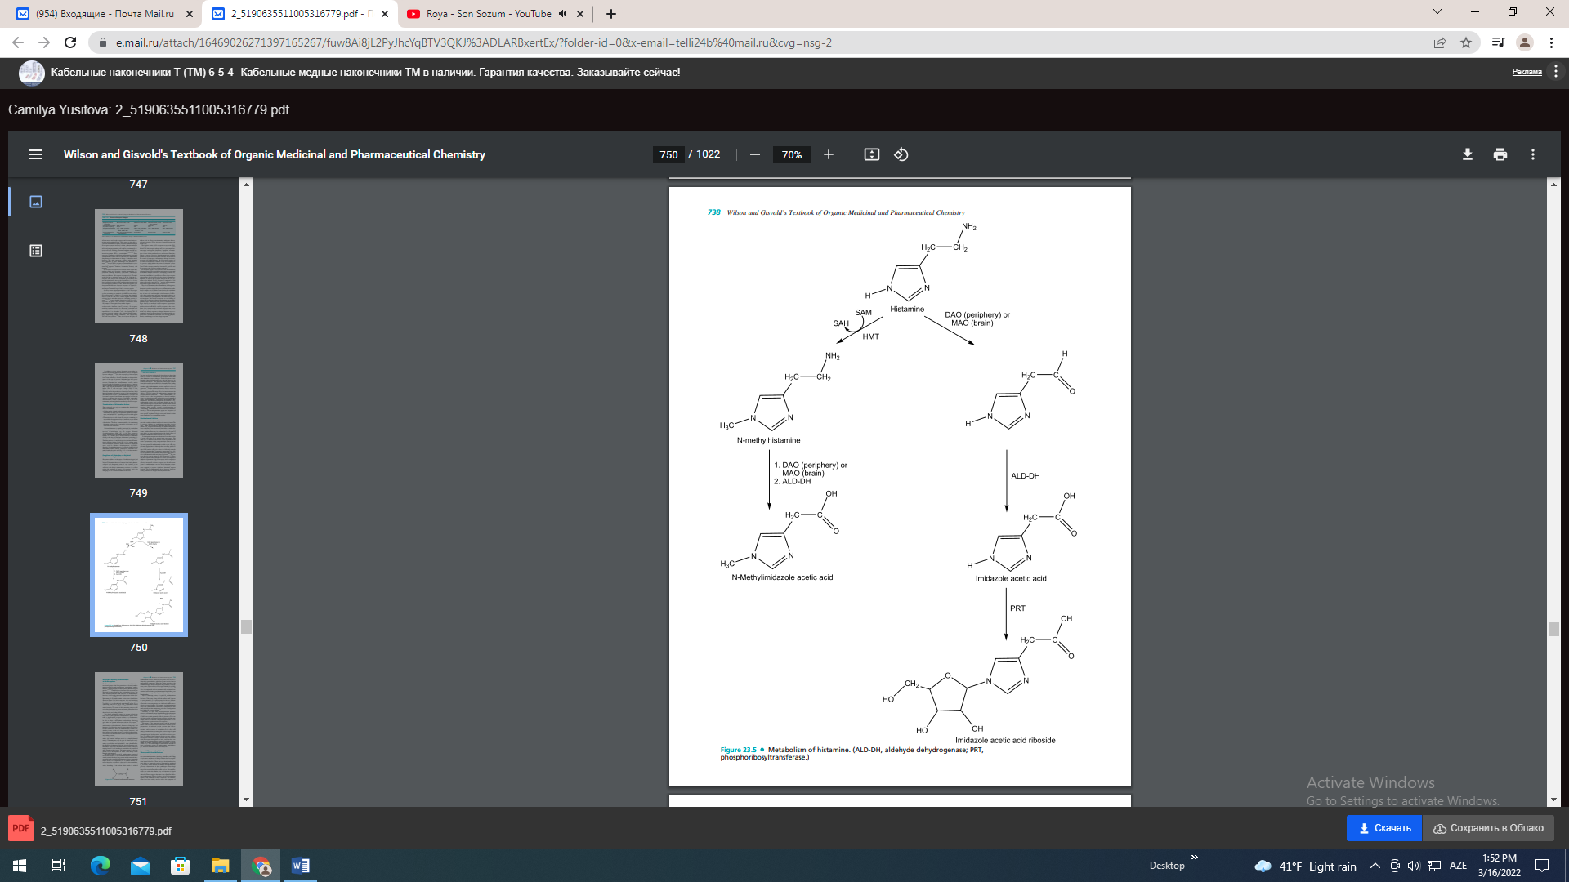

Structure-Activity Relationships at H1-Receptors
The H1-antihistamines are now commonly subdivided into two broad groups-the first-generation or classical antihistamines and the second-generation or “nonsedating” antihistamines-based primarily on their general pharmacological profiles.10,23,27 The differences between these two series are discussed in more detail in the sections that follow. The most detailed published SAR analyses for antihistamines, however, focus on the structural requirements for the firstgeneration agents.22–24 From these studies, the structural requirements for H1-antihistaminic action were identified as shown in Figure 23.6. In this structure, Ar is aryl (including phenyl, substituted phenyl, and heteroaryl groups such as 2-pyridyl); Ar' is a second aryl or arylmethyl group; X is a connecting atom of O, C, or N; (CH2)n represents a carbon chain, usually ethyl; and NRR' represents a basic, terminal amine function. The nature of the connecting atom as well as the diaryl substitution pattern and amine moiety has been used to subclassify the first-generation antihistamines as indicated in the succeeding sections. This diaryl substitution pattern is present in both the first- and second-generation antihistamines and is essentially a significant H1-receptor affinity.22–24 Furthermore, several SAR studies suggest that the two aryl moieties must be able to adopt a noncoplanar conformation relative to each other for optimal interaction with the H1-receptor.28 The two aromatic systems may be linked, as in the tricyclic antihistamines (phenothiazines, dihenzocycloheptanes, and heptenes), but again they must be noncoplanar for effective receptor interaction. Most H1-antihistamines contain substituents in one of the aryl rings (usually benzene), and these influence histamine potency as well as biodisposition, as discussed for the individual classes of compounds in the succeeding sections. In many of the first-generation, or classical, antihistamines, the terminal nitrogen atom is a simple dimethyl moiety. The amine may also be part of a heteroyclic structure, however, as illustrated by the piperazines, some propylamines (pyrrolidines and piperidines), some phenthiazines, the dibenzocycloheptenes, and the second-generation antihistamines. In all cases, the amino moiety is basic, with pKas ranging from 8.5 to 10, and thus is presumed to be protonated when bound on the receptor. The amine moiety is also important in the development of stable, solid dosage forms through salt formation.
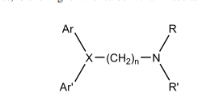
The carbon chain of typical H1-antihistamines consists of two or three atoms.22–24 As a result, the distance between the central point of the diaryl ring system and the terminal nitrogen atom in the extended conformation of these compounds ranges from 5 to 6 angstroms (Å). A similar distance between these key moieties is observed for those antihistamines with less conformational freedom. In some structural series, branching of the carbon chain results in reduced antihistaminic activity. There are exceptions, however, as evidenced by promethazine, which has greater activity than its nonbranched counterpart. When the carbon adjacent to the terminal nitrogen atom is branched, the possibility of asymmetry exists. Stereoselective H1-receptor binding is typically not observed, however, when chirality exists at this site.29 Also, in compounds with an asymmetrically substituted unsaturated carbon chain (pyrrobutamine and triprolidine), one geometric isomer typically displays higher receptor affinity than the other. The X connecting moiety of typical H1-antihistamines may be a saturated carbon–oxygen moiety or simply a carbon atom. This group, along with the carbon chain, appears to serve primarily as a spacer group for the key pharmacophoric moieties. Many antihistamines containing a carbon atom in the connecting moiety are chiral and exhibit stereoselective receptor binding. For example, in the pheniramine series and carbinoxamine, this atom is chiral, and in vitro analyses indicate that enantiomers with the S configuration have higher H1-receptor affinity.30 Generally, the first- and second-generation antihistamines are substantially more lipophilic than the endogenous agonist, histamine (or the H2-antagonists).31 This lipophilicity difference results primarily from the presence of the two aryl rings and the substituted amino moieties and thus may simply reflect the different structural requirements for antagonist versus agonist action at H1-receptors. The nature of the connecting moiety and the structural nature of the aryl moieties have been used to classify the antihistarnines as indicated in the sections that follow. Furthermore, variations in the diaryl groups, X-connecting moieties, and the nature of substitution in the alkyl side chain or terminal nitrogen among the various drugs account for differences observed in antihistaminic potency as well as pharmacological, biodisposition, and adverse reaction profiles. The ability of these drugs to display an array of pharmacological activities is largely because they can interact with H1-receptors throughout the body, and that they contain the basic pharmacophore required for binding to muscarinic as well as adrenergic and serotonergic receptors (Table 23.2). The relationships of antihistamine structure to these overlapping actions (H1-anthistaminic, anticholinergic, and local anesthetic) have been analyzed.
General Pharmacological and Therapeutic Considerations
The classical antihistamines have been used extensively for the symptomatic treatment (sneezing, rhinorrhea, and itching of eyes, nose, and throat) of allergic rhinitis (hay fever, pollinosis), chronic idiopathic urticaria, and several other histamine-related diseases. These uses are clearly attributed to their ability to counter the action of histamine at peripheral H1-receptors, which mediate the immune and inflammatory processes characteristic of these pathologies. These drugs best relieve the symptoms of allergic diseases at the beginning of the season when pollen counts are low. The antihistamines also reduce the number, size, and duration of wheals and itching in chronic urticaria when used promptly. Most clinical evidence suggests that there is no significant difference in therapeutic efficacy for first- and second-generation agents in the treatment of these conditions. The antihistamines have been widely used to relieve the symptoms of asthma and upper respiratory infections including the common cold, otitis media, and sinusitis. Most clinical evidence10 does not support such use unless asthma or infection is accompanied by allergic inflammation. Also, the antihistamines should not be used alone in analphylaxis, but may be used with epinephrine to relieve any H1-receptor–mediated symptoms.
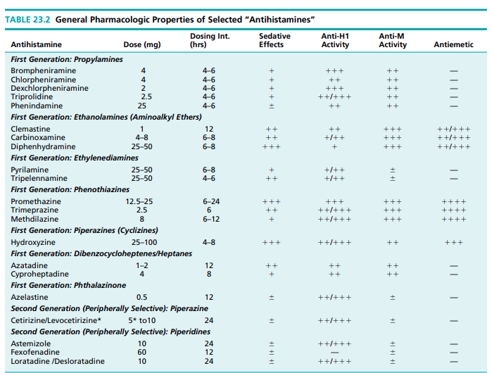
As the aforementioned general pharmacological profiles suggests, many antihistamines can interact with various neurotransmitter receptors and other biomacromolecular targets.10 This is most evident among the first-generation agents, many of which function as antagonists at muscarinic receptors and, to a lesser extent, adrenergic, serotonergic, and dopamine receptors. The first-generation agents also tend to achieve and maintain higher levels in the brain than the second-generation agents, resulting in CNS-based pharmacologic actions.10 Although some of these non–target-receptor interactions may have therapeutic value (as discussed next), more frequently they are manifested as adverse reactions that limit drug use. This is particularly true of the peripheral anticholinergic effects produced by these drugs and of interactions with several neurotransmitter systems in the CNS that result in sedation, fatigue, and dizziness (see Table 23.2). Several first-generation antihistamines, particularly the phenothiazines and aminoalkyl ethers, have antiemetic actions and thus may be useful in the treatment of nausea and vomiting and for vertigo and motion sickness.10,26,27 Several of the phenothiazines have limited use in parkinsonism as a result of their ability to block central muscarinic receptors.10,26,27 Antihistamines, including promethazine, pyrilamine, tripelennamine, and diphenhydramine, also display local anesthetic activity that may be therapeutically useful.32 Many of the first-generation antihistamines readily penetrate the blood-brain barrier (BBB) because of their lipophilicity, and maintain significant CNS concentrations because they are not substrates for P-glycoprotein effluxs pump that are expressed on endothelial cells of the CNS vasculature. The lack of affinity by P-glycoprotein efflux pumps appears to be directly related to the relatively low molecular weight and small size of the first-generation antihistamines.10,33 Blockade of central H1-receptors results in sedation, an effect that has contributed to the historical use of antihistamines as nonprescription sleep aids, as well as drugs for perioperative sedation.10 However, the sedative actions of antihistamines are undesired effects in the treatment of allergy-based diseases. Furthermore, the blockade of central H1-receptors also results in decreased cognitive and psychomotor performance, as well as increased appetite and weight gain, all considered to be therapy-limiting adverse effects.
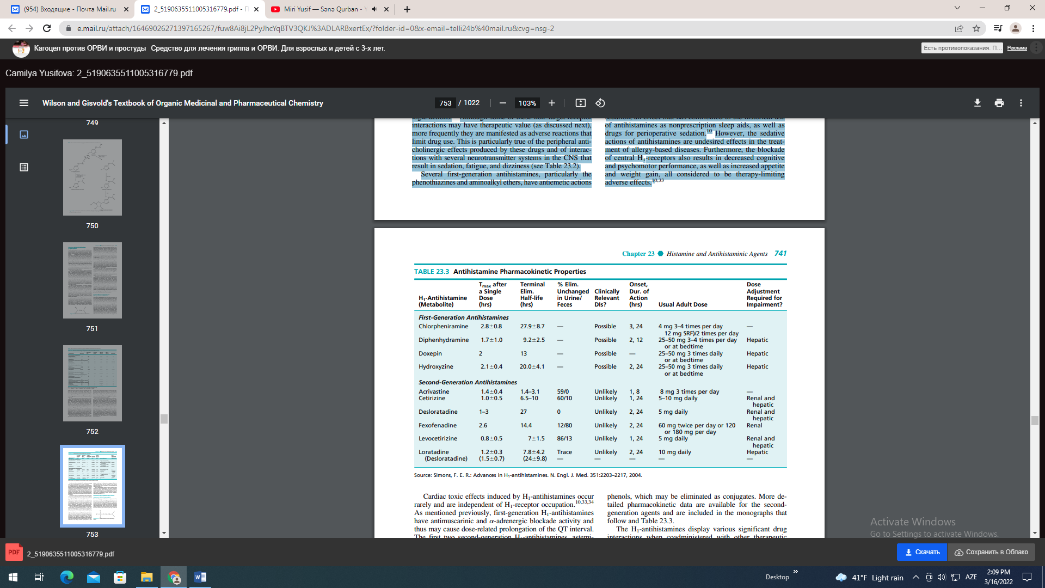

Cardiac toxic effects induced by H1-antihistamines occur rarely and are independent of H1-receptor occupation.10,33,34 As mentioned previously, first-generation H1-antihistamines have antimuscarinic and -adrenergic blockade activity and thus may cause dose-related prolongation of the QT interval. The first two second-generation H1-antihistamines, astemizole and terfenadine, were found to be even more cardiotoxic than the first-generation agents, especially when used in combination with other drugs. This led to their withdrawal from the market. The cardiac effects of the second-generation antihistamines are discussed in more detail in the next section of this chapter. The primary objective of antihistamine drug development over the past several decades has centered on developing new drugs with higher selectivity for H1-receptors and lacking undesirable CNS and cardiovascular actions.10,33,34 These efforts led to the introduction of the second-generation antihistamines, which are classified as “nonsedating” and have little antagonist activity at other neurotransmitter receptors, including muscarinic receptors, and cardiac ion channels at therapeutic concentrations. The pharmacological properties of these agents will be discussed in more detail. There are relatively few published studies concerning the pharmacokinetic and biodisposition profiles of the firstgeneration antihistamines.10,31 Generally, the compounds are orally active and well absorbed, but oral bioavailability may be limited by first-pass metabolism. The metabolites formed depend on drug structure to a large extent but commonly involve the tertiary amino moiety. This functionality may be subject to successive oxidative N-dealkylation, deamination, and amino acid conjugation of the resultant acid. The amine group may also undergo N-oxidation (which may be reversible) or direct glucuronide conjugation. First-generation agents with unsubstituted and activated aromatic rings (phenothiazines) may undergo aromatic hydroxylation to yield phenols, which may be eliminated as conjugates. More detailed pharmacokinetic data are available for the secondgeneration agents and are included in the monographs that follow and Table 23.3. The H1-antihistamines display various significant drug interactions when coadministered with other therapeutic agents. For example, MAO inhibitors prolong and intensify the anticholinergic actions of the antihistamines. Also, the sedative effects of these agents may potentiate the depressant activity of barbiturates, alcohol, narcotic analgesics, and other depressants.10,23,31 First-Generation Antihistamine Classes
AMINOALKYL ETHERS (ETHANOLAMINES)
The aminoalkyl ether antihistamines are characterized by the presence of a CHO connecting moiety (X) and a two- or three-carbon atom chain as the linking moiety between the key diaryl and tertiary amino groups (Fig. 23.7). Most compounds in this series are simple N, N-dimethylethanolamine derivatives and are so classified in several texts. Clemastine and diphenylpyraline differ from this basic structural pattern, in that the basic nitrogen moiety and at least part of the carbon chain are part of a heterocyclic ring system and there are three carbon atoms between the oxygen and nitrogen atoms. The basic nitrogen in all of these compounds is not only essential for binding affinity, but also serves as a moiety for the formation of stable, solid salts.
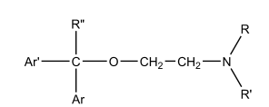
The simple diphenyl derivative diphenhydramine was the first clinically useful member of the ethanolamine series and serves as the prototype. Other therapeutically useful derivatives of dipherthydraniine have been obtained by para substitution of methyl (methyldiphenhydramine), methoxy (medrylamine), chloro (chlorodiphenhydramine), or bromo (bromodiphenhydramine) on one of the phenyl rings. These derivatives reportedly have better therapeutic profiles than diphenhydramine because of reduced adverse effects.10,31 Replacement of one of the phenyl rings of the diphenhydramine with a 2-pyridyl group, as in doxylamine and carbinoxamine, enhances antihistaminic activity as demonstrated by pA2 values in vitro and therapeutic dosing data (Table 23.2). These compounds display oral antihistaminic activities 40 and 2 greater, respectively, than diphenhydramine in animal test models.31 As a result of an asymmetrically substituted benzylic carbon, most of the aminoalkyl ethers are optically active. Most studies indicate indicate that the individual enantiomers differ significantly in antihistaminic activity, with activity residing predominantly in the S-enantiomers.30,35 The diaryl tertiary aminoalkyl ether structure that characterizes these compounds also serves as a pharmacophore for muscarinic receptors (Table 23.2). As a result, the drugs in this group possess significant anticholinergic activity, which contributes not only to their therapeutic use as antiemetic, motion sickness, and anti-Parkinson drugs but also to their adverse effect profile (dry mouth, blurred vision, urinary retention, constipation, tachycardia). Drowsiness, as well as other CNS effects, is a common side effect to the tertiary aminoalkyl ethers, presumably as a result of the ability of these compounds to penetrate the BBB and occupy central H1-receptors. Although this central action is exploited in over-the-counter (OTC) sleeping aids, it may interfere with the performance of tasks requiring mental alertness.10,26,27 The frequency of GI side effects in this series of antihistamines is relatively low, compared with the ethylenediamine antihistamines.10,26,27 In spite of their long and extensive use, pharmacokinetic data on this series of compounds are relatively limited. Most members of this series appear to be extensively metabolized by pathways including N-oxidation and successive oxidative N-dealkylation followed by aldehyde oxidation and amino acid conjugation.31 The known kinetic properties of representative members of this class of antihistamines are summarized in Table 23.3.10 The structures of the aminoalkyl ether derivatives with physicochemical properties, basic therapeutic activty data, and dosage form information are provided in the monographs that follow.
Diphenhydramine Hydrochloride, Tannate, and Citrate.
Diphenhydramine hydrochloride, 2-(diphenylmethoxy)-N,N-dimethylethanamine hydrochloride (Benadryl), is an oily, lipid-soluble free base available as the bitter-tasting hydrochloride salt, which is a stable, white crystalline powder soluble in water (1:1), alcohol (1:2) and chloroform (1:2). The salt has a pKa value of 9, and a 1% aqueous solution has a pH of about 5. The other salts display comparable properties. In addition to antihistaminic action, diphenhydramine exhibits antidyskinetic, antiemetic, antitussive and antimuscarinic, and sedative properties.

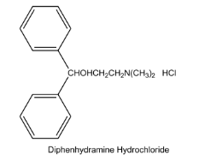
In the usual dose range of 25 to 400 mg, diphenhydramine is not a highly active H1- antihistamine. Conversion to a quaternary ammonium salt does not alter the antihistaminic action greatly but does increase the anticholinergic action. As an antihistaminic agent, diphenhydramine is recommended in various allergic conditions and, to a lesser as an antitussive and Parkinsonism drug. It is also used in OTC sleep-aid products. It is administered either orally or parenterally in the treatment of urticaria, seasonal rhinitis (hay fever), and some dermatoses. The most common side effect is drowsiness, and the concurrent use of alcohol and other CNS depressants should be avoided. Dosage forms: Tablets (12.5, 25, and 50 mg); capsules (25 and 50 mg); oral disintegrating strips (12.5 and 25 mg); solutions, elixirs, and syrups (12.5 mg/5 mL); suspension (25 mg/5 mL); and injection (50 mg/mL). Usual adult doses: • Antihistamine: 25 to 50 mg every 4 to 6 hours (maximum of 300 mg/day) • Antitussive liquid: 25 to 50 mg every 4 hours (liquid) or 25 mg every 4 hours (syrup); do not exceed 300 mg/day • Motion sickness: 25 to 50 mg every 4 to 6 hours (maximum of 300 mg/day) Dimenhydrinate. The 8-chlorotheophyllinate (theoclate) salt of diphenhydramine, 8-chlorotheophylline 2-(diphenylmethoxy)-N,N-dimethylethylamine (Dramamine), is a white crystalline, odorless powder that is highly soluble in water and freely soluble in alcohol and chloroform. Dimenhydrinate is recommended for nausea of motion sickness and for hyperemesis gravidarum (nausea of pregnancy). For the prevention of motion sickness, the dose should be taken at least 0.5 hour before beginning a trip. The cautions listed for diphenhydramine should be observed. Dosage forms: Tablets (50 mg), liquid (12.5 mg/5 mL, 15.62 mg/5 mL), injection (50 mg/mL) Usual dosage (motion sickness): • Adult/children 12 years of age: 1 to 2 chewable tablets or tablets (50–100 mg) every 4 to 6 hours, not to exceed 8 chewable tablets or tablets (400 mg) in 24 hours
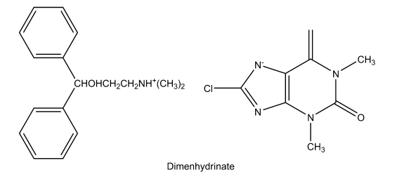
• Children 6 to younger than 12 years of age: 1 ⁄2 to 1 chewable tablet or tablet (25–50 mg) every 6 to 8 hours, not to exceed 3 tablets in 24 hours • Children 2 to younger than 6 years of age: 1 ⁄4 to 1 ⁄2 chewable tablet or tablet (12.5–25 mg) every 6 to 8 hours, not to exceed 1 1 ⁄2 tablets in 24 hours
Bromodiphenhydramine Hydrochloride.
Bromodiphenhydramine hydrochloride, 2-[(4-bromophenyl)- phenylmethoxy]-N, N-dimethylethanamine hydrochloride (Ambodryl Hydrochloride), is a white to pale buff crystalline powder that is freely soluble in water and in alcohol. Relative to diphenhydramine, bromodiphenhydramine is more lipid soluble and was twice as effective in protecting against the lethal effects of histamine aerosols.
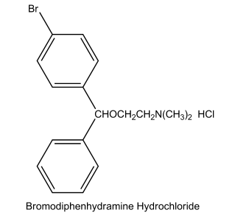
Dosage forms: Capsules and elixir Usual adult dose: Oral, 25 mg/4 to 6 hours
Doxylamine Succinate. The acid succinate salt (bisuccinate) of doxylamine, 2-[-[2-(dimethylamino)ethoxy]-- methylbenzyl]pyridine bisuccinate (Decapryn Succinate), is a white to creamy-white powder with a characteristic odor. It is soluble in water (1:1), alcohol (1:2), and chloroform (1:2). A 1% solution has a pH of about 5.
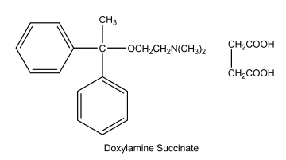
Doxylamine succinate is comparable in potency to diphenhydramine. It is indicated for the relief of seasonal rhinitis symptoms, but is also used as a nighttime sedative. Concurrent use of alcohol and other CNS depressants should be avoided. Dosage forms: Tablets (5 mg), oral suspension (1 mg/mL), and oral liquid (2.5 mg/2.5 mL) Usual adult dose: Oral, 12.5 to 25 mg/4 to 6 hours Carbinoxamine Maleate. Carbinoxamine is available as a bitter bimaleate salt, (d, l)-2-[p-chloro--[2-(dimethylamino)ethoxy]benzyl]pyridine bimaleate (Clistin), which is a white crystalline powder that is very soluble in water and freely soluble in alcohol and in chloroform. The pH of a 1% solution is between 4.6 and 5.1.

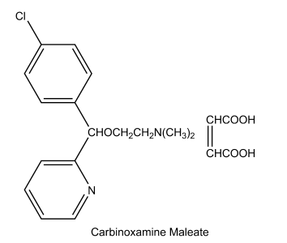
Carbinoxamine is a potent antihistaminic and is available as the racemic mixture. It differs structurally from chlorpheniramine only in having an oxygen atom separate the asymmetric carbon atom from the aminoethyl side chain. The more active levo isomer of carbinoxamine has the (S) absolute configuration30 and can be superimposed on the more active dextro isomer (S configuration) of chlorpheniramine. Dosage forms: Tablets (4 and 8 mg), capsules (10 mg), liquid (1.67 mg/5 mL), solution (4 mg/5 mL), and suspension (3.2 mg/5 mL) Usual dose (tablets): • Adults and children 12 years of age and older: 1 tablet (8 mg) twice daily • Children 6 to 12 years of age: 1 ⁄2 tablet twice daily (every 12 hours). The tablets are not recommended for children younger than 6 years of age.
Clemastine Fumarate. Dextrorotatory clemastine, R,R-2[2[1-(4-chlorophenyl)-1-phenylethoxy]ethyl]-1- methylpyrrolidine hydrogen furnarate (1:1) (Tavist), has two chiral centers, each of which has the (R) absolute configuration. A comparison of the activities of the enantiomers indicates that the asymmetric center close to the terminal side chain nitrogen is of lesser importance to antihistaminic activity.36 This member of the ethanolamine series is characterized by a long duration of action, with an activity that reaches a maximum in 5 to 7 hours and persists for 10 to 12 hours. It is well absorbed when administered orally, and it is excreted primarily in the urine. The side effects are those usually encountered with this series of antihistamines. Clemastine is closely related to chlorphenoxamine, which is used for its central cholinergic-blocking activity. Therefore, it is not surprising that clemastine has significant antimuscarinic activity. Dosage forms: Tablets (1.34 and 2.68 mg) and syrup (0.67 mg/5 mL) Usual adult dose:
• Allergic rhinitis: 1.34 mg every 12 hours or twice daily (maximum 8.04 mg/day for the syrup or 2.68 mg in 24 hours for the tablets) for adults; 0.67 mg twice daily (maximum 4.02 mg) for children 6 to 12 years of age (syrup only)
• Urticaria/angioedema: 2.68 mg twice daily, not to exceed 8.04 mg/day for adults; 1.34 mg twice daily, not to exceed 4.02 mg/day for children 6 to 12 years of age (syrup only)
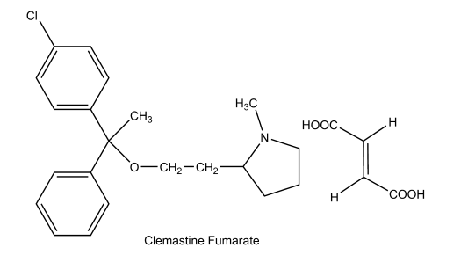
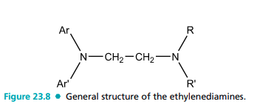
Diphenylpyraline Hydrochloride. Diphenylpyr aline hydrochloride, 4-(diphenylmethoxy)-1-methylpiperidine hydrochloride (Hispril, Diafen) is a white or slightly offwhite crystalline powder that is soluble in water or alcohol. Diphenylpyraline is structurally related to diphenhydramine with the aminoalkyl side chain incorporated in a piperidine ring. It is a potent antihistaminic, and the usual dose is 2 mg 3 or 4 times daily.
ETHYLENEDIAMINES
The ethylenediamine antihistamines are characterized by the presence of a nitrogen-connecting atom (X) and a two-carbon atom chain as the linking moiety between the key diaryl and tertiary amino moieties (Fig. 23.8). All compounds in this series are simple diarylethylenediamines except antazoline, in which the terminal amine and a portion of the carbon chain are included as part of an imidazoline ring system. Because it differs significantly in its pharmacological profile, antazoline is not always classified as an ethylenediamine derivative. Phenbenzamine was the first clinically useful member of this class and served as the prototype for the development of more effective derivatives. Replacement of the phenyl moiety of phenbenzamine with a 2-pyridyl system yielded tripelennamine, a significantly more effective histamine receptor blocker as was also observed in the aminoalkyl ether series described previously.31 Substitution of a para methoxy (pyrilamine or mepyramine), chloro (chloropyramine), or bromo (bromtripelennamine) further enhances activity, as observed earlier. Replacement of the benzyl group of tripelennamine with a 2-thienylmethyl group provided methapyrilene, and replacement of tripelennamine’s 2-pyridyl group with a pyrimidinyl moiety (along with p-methoxy substitution) yielded thonzylamine, both of which function as potent H1-receptor antagonists.31 In all of these compounds, the aliphatic or terminal amino group is required for H1-blocking activity and is significantly more basic than the nitrogen atom bonded to the diaryl moiety; the nonbonded electrons on the diaryl nitrogen are delocalized by the aromatic ring, and the resultant reduction in electron density on nitrogen decreases basicity. Thus, the aliphatic amino group in the ethylenediamines is sufficiently basic for the formation of pharmaceutically useful salts. Historically, the ethylenediamines were among the first useful antihistamines. They are moderately effective H1-antihistamines based on pA2 values and doses, but they also display a relatively high frequency of CNS depressant and GI side effects.27,31 The anticholinergic and antiemetic actions of these compounds are relatively low compared with those of most other classical, first-generation antihistamines (Table 23.2). The piperazine- and phenothiazine-type antihistamines also contain the ethylenediamine moiety, but these agents are discussed separately because they exhibit significantly different pharmacological properties. Relatively little information is available concerning the pharmacokinetics of this series of compounds. Tripelennamine is metabolized in humans by N-glucuronidation, N-oxidation, and pyridyl oxidation followed by phenol glucuronidation. It is anticipated that other members of this series are similarly metabolized.31 The known pharmacokinetic properties of representative members of this class of antihistamines are summarized in Table 23.3. The structures of the salt forms of the marketed ethylenediamine antihistamines, along with physicochemical properties, therapeutic activity profiles, and dosage form information, are provided in the monographs that follow. Tripelennamine Citrate. Tripelennamine citrate, 2-[benzyl[2-dimethylamino)-ethyl]amino]pyridine citrate (1:1), PBZ (Pyribenzamine Citrate), is available as a monocitrate salt, which is a white crystalline powder freely soluble in water and in alcohol. A 1% solution has a pH of 4.25. For oral administration in liquid dose forms, the citrate salt is less bitter and thus more palatable than the hydrochloride. Because of the difference in molecular weights, the doses of the two salts must be equated 30 mg of the citrate salt is equivalent to 20 mg of the hydrochloride salt.
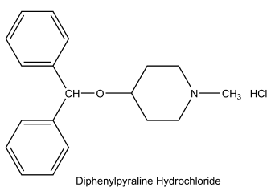
Dosage forms: Elixir Usual adult dose: Oral, 25 to 50 mg/4 to 6 hours Tripelennamine Hydrochloride. Tripelennamine hydrochloride is a white crystalline powder that darkens slowly on exposure to light. The salt is soluble in water (1:0.77) and in alcohol (1:6). It has a pKa of about 9, and a 0.1% solution has a pH of about 5.5. Tripelennamine, the first ethylenediamine developed in the United States and is well absorbed when given orally. It appears to be as effective as diphenhydramine and may have the advantage of fewer and less severe side reactions. Drowsiness may occur, however, and may impair the ability to perform tasks requiring alertness. The concurrent use of alcoholic beverages should be avoided. Dosage forms: Tablets, extended-release tablets Usual adult dose: Oral tablets, 25 to 50 mg/4 to 6 hours; extended-release tablets, 100 mg/8 to l2 hours Pyrilamine Maleate. Pyrilamine, 2-[4-methoxybenzyl [2-dimethylamino)ethyl]-amino]pyridine, is available as the acid maleate salt (1:1), which is a white crystalline powder with a faint odor and a bitter, saline taste. The salt is soluble in water (1:0.4) and freely soluble in alcohol. A 10% solution has a pH of approximately 5. At a pH of 7.5 or above, the free base begins to precipitate.
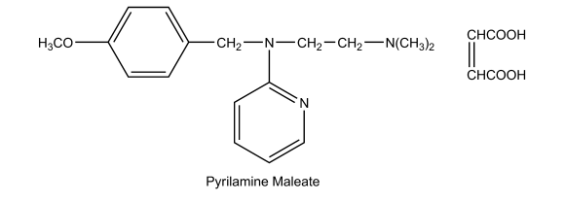
Pyrilamine differs structurally from tripelennamine by having a methoxy group in the para position of the benzyl radical. It differs from its more toxic and less potent precursor phenbenzamine (Antergan) by having a 2-pyridyl group on the nitrogen atom in place of a phenyl group. Clinically, pyrilamine and tripelennamine are considered among the less potent antihistaminics. They are highly potent, however, in antagonizing histamine-induced contractions of guinea pig ileum.22 Because of the pronounced local anesthetic action, the drug should not be chewed, but taken with food. Dosage forms: Tablets Usual adult dose: Oral, 25 to 50 mg/6 to 8 hours Methapyrilene Hydrochloride. Methapyrilene hydrochloride, 2-[[2-(dimethylamino)-ethyl]-2-thienylarnino] pyridine monohydrochloride (Histadyl) is available as the bitter-tasting, white crystalline powder that is soluble in water (1:0.5), in alcohol (1:5), and in chloroform (1:3). Its solutions have a pH of about 5.5. It differs structurally from tripelennamine in having a 2-thiophene—methylene group in place of the benzyl group. The thiophene ring is considered isosteric with the benzene ring, and the isosteres exhibit similar activity. A study of the solid-state conformation of methapyrilene hydrochloride showed that the trans-conformation is preferred for the two ethylenediamine nitrogen atoms. The Food and Drug Administration declared methapyrilene a potential carcinogen in 1979, and all products containing it have been recalled.
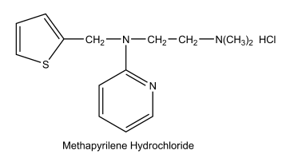
Thonzylamine Hydrochloride. Thonzylamine hydrochloride, 2-[[2-(dimethylamino)-ethyl](p-methoxybenzyl)amino]pyrimidine hydrochloride, is a white crystalline powder soluble in water (1:1), in alcohol (1:6), and in chloroform (1:4). A 2% aqueous solution has a pH of 5.5. It issimilar in activity to tripelennamine but is claimed to be less toxic. The usual dose is 50 mg taken up to 4 times daily. It is available in certain combination products. Antazoline Phosphate. Antazoline phosphate, 2-[(Nbenzylanilino)methyl]-2-imidazoline dihydrogen phosphate, is a bitter, white to off-white crystalline powder that is soluble in water. It has a pKa of 10.0, and a 2% solution has a pH of about 4.5. Antazoline, like the ethylenediamines, contains an N-benzylanilino group linked to a basic nitrogen through a two-carbon chain.
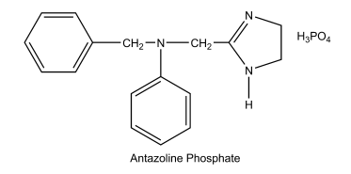
Antazoline is less active than most of the other antihistaminic drugs, but it is characterized by the lack of local irritation. The more soluble phosphate salt is applied topically to the eye in a 0.5% solution. The less soluble hydrochloride is given orally. In addition to its use as an antihistamine, antazoline has more than twice the local anesthetic potency of procaine and also exhibits anticholinergic actions. PIPERAZINES (CYCLIZINES) The piperazines or cyclizines can also be considered ethylenediamine derivatives or cyclic ethylenediamines (cyclizines); in this series, however, the connecting moiety (X) is a CHN group, and the carbon chain, terminal amine functionality, and the nitrogen atom of the connecting group are all part of a piperazine moiety (Fig. 23.9). Both nitrogen atoms in these compounds are aliphatic and thus display comparable basicities. The primary structural differences within this series involve the nature of the para aromatic ring substituent (H or Cl) and, more importantly, the nature of the terminal piperazine nitrogen substituent. The piperazines are moderately potent antihistaminics with a relatively high potential to cause drowsiness and psychomotor and cognitive dysfunction (Table 23.2).26,27,31 The activity of the piperazine-type antihistaminics is characterized by a slow onset, but a long duration of action. These agents exhibit peripheral and central antimuscarinic activity, and thereby diminish vestibular stimulation and act on the medullary chemoreceptor trigger zone.10,26,27 Thus, as a group, these agents have found significant use as antiemetics and antivertigo agents and in the treatment of motion sickness (Table 23.2). Some members of this series have exhibited a strong teratogenic potential, inducing several malformations in animal models. The N-dealkylayed metabolites, the norchlorcyclizines, have been proposed as responsible for the teratogenic effects of the parent drugs.37 Although teratogenicity has not been observed in humans, its use during pregnancy is discouraged. Metabolic studies in this series of compounds have focused primarily on cyclizine and chlorcyclizine, and these compounds undergo similar biotransformation. The primary pathways involve N-oxidation and N-demethylation, and both of these metabolites are devoid of antihistaminic activity. The structures of the marketed salt forms of the piperazine antihistamines, along with physicochemical properties, basic therapeutic activity profiles, and dosage form information, are provided in the monographs that follow. The known kinetic properties of representative members of this class of antihistamines are summarized in Table 23.3.
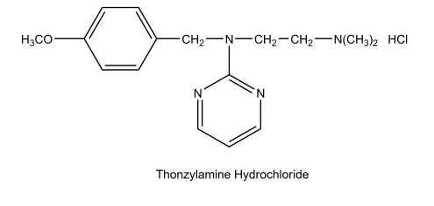
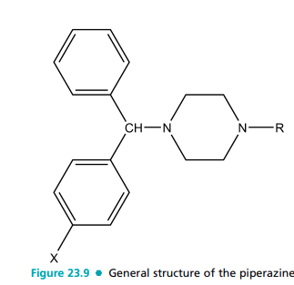
Cyclizine Hydrochloride. Cyclizine hydrochloride, 1-(diphenylmethyl)-4-methylpiperazine monohydrochloride (Marezine), occurs as a light-sensitive, white crystalline powder with a bitter taste. It is slightly soluble in water (1:115), in alcohol (1:115), and in chloroform (1:75). It is used primarily in the prophylaxis and treatment of motion sickness. The lactate salt (Cyclizine Lactate Injection, United States Pharmacopoeia [USP]) is used for intramuscular (IM) injection because of the limited water solubility of the hydrochloride. The injection should be stored in a cold place, because if it is stored at room temperature for several months, a slight yellow tint may develop. This does not indicate a loss in biologic potency.
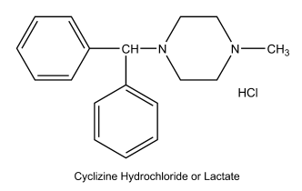
Dosage forms: Tablets HCl (25 and 50 mgHC1) and injection (lactate) Usual adult dose: 1 tablet every 4 to 6 hours for adults and children 12 years of age and older; 1 ⁄2 tablet every 6 to 8 hours, not to exceed 11 ⁄2 tablets in 24 hours for children from 6 to 12 years of age Chlorcyclizine Hydrochloride. Chlorcyclizine hydrochloride, 1-(p-chloro--phenylbenzyl)-4-methylpiperazine monohydrochioride, is a light-sensitive, white crystalline powder that is soluble in water (1:2), in alcohol (1:11), and in chloroform (1:4). A 1% solution has a pH between 4.8 and 5.5. Disubstitution or substitution of halogen in the 2- or 3-position of the benzhydryl rings results in a much less potent compound. Chlorcydizine is indicated for the symptomatic relief of urticaria, hay fever, and certain other conditions. Meclizine Hydrochloride. Meclizine hydrochloride, 1-(p-chloro--phenylbenzyl)-4-(m-methylbenzyl)piperazine dihydrochloride monohydrate (Bonine, Antivert), is a tasteless, white or slightly yellowish crystalline powder that
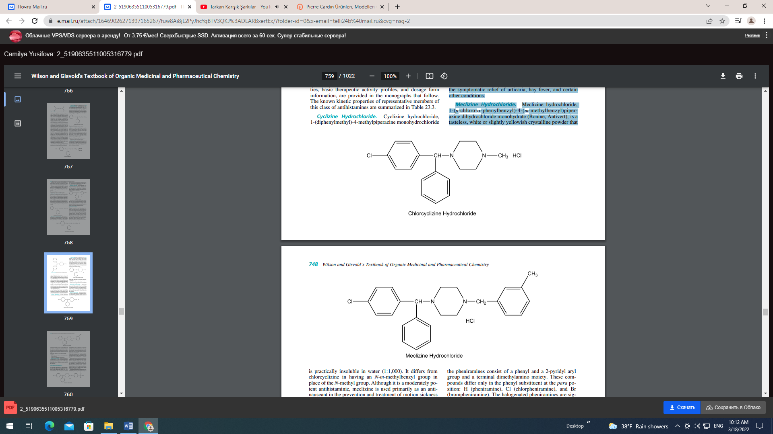

is practically insoluble in water (1:1,000). It differs from chlorcyclizine in having an N-m-methylbenzyl group in place of the N-methyl group. Although it is a moderately potent antihistaminic, meclizine is used primarily as an antinauseant in the prevention and treatment of motion sickness and in the treatment of nausea and vomiting associated with vertigo. Dosage forms: Tablets (12, 5, 25, 50 mg) and capsules (25 mg) Usual adult dose: • Motion sickness: 25- to 50-mg meclizine HCl should be taken 1 hour prior • Vertigo: 25 to 100 mg daily in divided doses Buclizine Hydrochloride. Buclizine hydrochloride, l- (p-tertbutylbenzyl)-4-(p-chloro--phenylbenzyl)piperazine dihydrochloride (Bucladin-S), is a white to slightly yellow crystalline powder that is insoluble in water. The highly lipid-soluble buclizine has CNS depressant, antiemetic, and antihistaminic properties. This drug has been discontinued in the United States. PROPYLAMINES (MONOAMINOPROPYL OR ALKYLAMINE DERIVATIVES) The propylamine antihistamines are characterized structurally by an sp3 or sp2 carbon-connecting atom with a carbon chain of two additional carbons linking the key tertiary amino and diaryl pharmacophore moieties (Fig. 23.10). Those propylamines with a saturated carbon-connecting moiety are commonly referred to as the pheniramines. All of the pheniramines consist of a phenyl and a 2-pyridyl aryl group and a terminal dimethylamino moiety. These compounds differ only in the phenyl substituent at the para position: H (pheniramine), Cl (chlorpheniramine), and Br (brompheniramine). The halogenated pheniramines are significantly more potent (20–50 times) and have a longer duration of action than pheniramine.31 All pheniramines are chiral molecules, and the halogensubstituted derivatives have been resolved by crystallization of salts formed with d-tartaric acid. Antihistaminic activity resides almost exclusively in the S-stereoisomers (200–1,000 times higher H1-receptor binding affinities).30,38 The pheniramines are widely used in OTC products for seasonal allergies. The propylamines with an unsaturated connecting moiety include the simple open-chain alkene derivatives pyrrobutarnine and triprolidine and the cyclic alkene analogs dirnethindene and phenindamine. In the open-chain propylamines, a coplanar aromatic double-bond system appears to be an important factor for antihistaminic activity. Also, these compounds are asymmetric and the E-isomers are significantly more potent than the Z-isomers.4,39 The pyrrolidino group of these compounds is the side chain tertiary amine that imparts greatest antihistaminic activity. The conformational rigidity of the cyclic alkene propylamines has provided a useful model to determine distances between the key diaryl and tertiary pharmacophoric moieties in H1-antagonists, a distance of 5 to 6 Å.39 The antihistamines in this group are among the most active H1-antagonists in terms of pA2 values and doses (Table 23.2 and 23.3). They also have greater receptor selectivity and
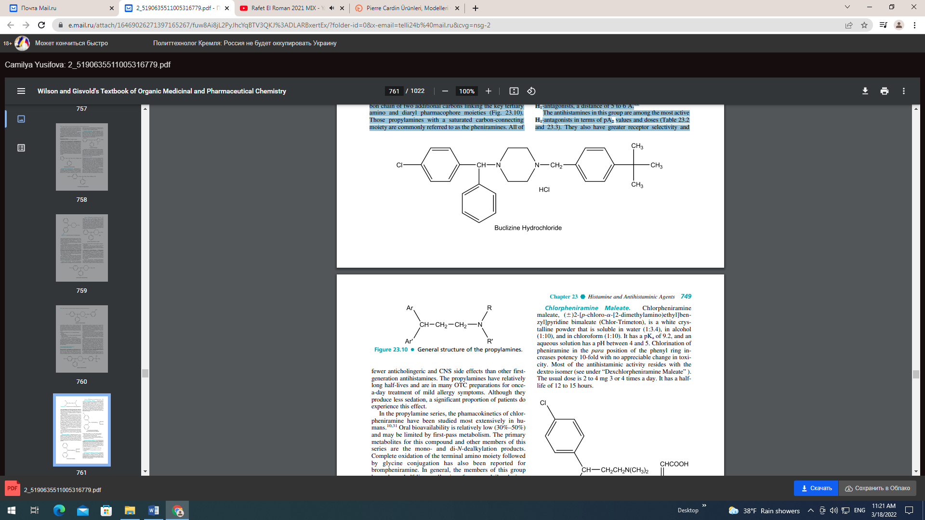
fewer anticholingeric and CNS side effects than other firstgeneration antihistamines. The propylamines have relatively long half-lives and are in many OTC preparations for oncea-day treatment of mild allergy symptoms. Although they produce less sedation, a significant proportion of patients do experience this effect. In the propylamine series, the phamacokinetics of chlorpheniramine have been studied most extensively in humans.10,31 Oral bioavailability is relatively low (30%–50%) and may be limited by first-pass metabolism. The primary metabolites for this compound and other members of this series are the mono- and di-N-dealkylation products. Complete oxidation of the terminal amino moiety followed by glycine conjugation has also been reported for brompheniramine. In general, the members of this group have long half-lives, allowing for once-daily dosing. Chlorpheniramine’s plasma half-life ranges from about 12 to 28 hours, depending on the route of administration (Table 23.3). The known kinetic properties of representative members of this class of antihistamines are summarized in Table 23.3. The structures of the marketed salt forms of the propylamine antihistamines, along with physicochemical properties, basic therapeutic activity profiles, and dosage form information, are provided in the monographs that follow. Pheniramine Maleate. Pheniramine maleate, 2-[-[2- dimethylaminoethyl]benzyl]-pyridine bimaleate (Trimeton, Inhiston), is a white crystalline powder, with a faint aminelike odor, which is soluble in water (1:5) and very soluble in alcohol. This drug is the least potent member of the series and is marketed as the racemate. The usual adult dose is 20 to 40 mg 3 times daily. It is available in certain combination products.
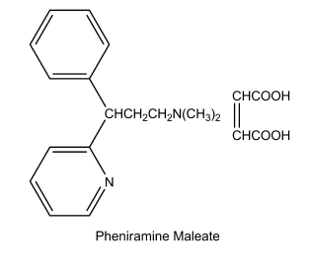
Chlorpheniramine Maleate. Chlorpheniramine maleate, ()2-[p-chloro--[2-dimethylamino)ethyl]benzyl]pyridine bimaleate (Chlor-Trimeton), is a white crystalline powder that is soluble in water (1:3.4), in alcohol (1:10), and in chloroform (1:10). It has a pKa of 9.2, and an aqueous solution has a pH between 4 and 5. Chlorination of pheniramine in the para position of the phenyl ring increases potency 10-fold with no appreciable change in toxicity. Most of the antihistaminic activity resides with the dextro isomer (see under “Dexchlorpheniramine Maleate” ). The usual dose is 2 to 4 mg 3 or 4 times a day. It has a halflife of 12 to 15 hours
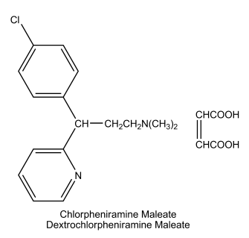
Dosage forms: Tablets (2, 4, 8, and 12 mg), extendedrelease capsules (8 and 12 mg), syrup (2 mg/5 mL), and oral suspension (4 and 8 mg/5 mL) Usual adult dose: Oral, 4 mg/4 to 6 hours; extended release, 8 to 12 mg/8 to 12 hours; IM, intravenous (IV), or subcutaneous, 5 to 40 mg
Dexchlorpheniramine Maleate.
Dexchlorpheniramine (Polaramine) is the dextrorotatory enantiomer of chlorpheniramine. In vitro and in vivo studies of the enantiomers of chlorpheniramine showed that the antihistaminic activity exists predominantly in the dextro isomer. As mentioned previously, the dextro isomer has the (S) configuration, which is superimposable on the (S) configuration of the more active levorotatory enantiomer of carbinoxamine.30 Dosage forms: Extended-release tablets (4 and 6 mg), syrup (2 mg/5mL) Usual adult dose: 4 or 6 mg at bedtime or every 8 to 10 hours Brompheniramine
Maleate and Tannate. Brompheniramine maleate, ()2-[p-bromo--[2-(dimethylamino) ethyl]benzyl]pyridine bimaleate (Dimetane), differs from chlorpheniramine by the substitution of a bromine atom for the chlorine atom. Its actions and uses are like those of chlorpheniramine. It has a half-life of 25 hours, which is almost twice that of chlorpheniramine.

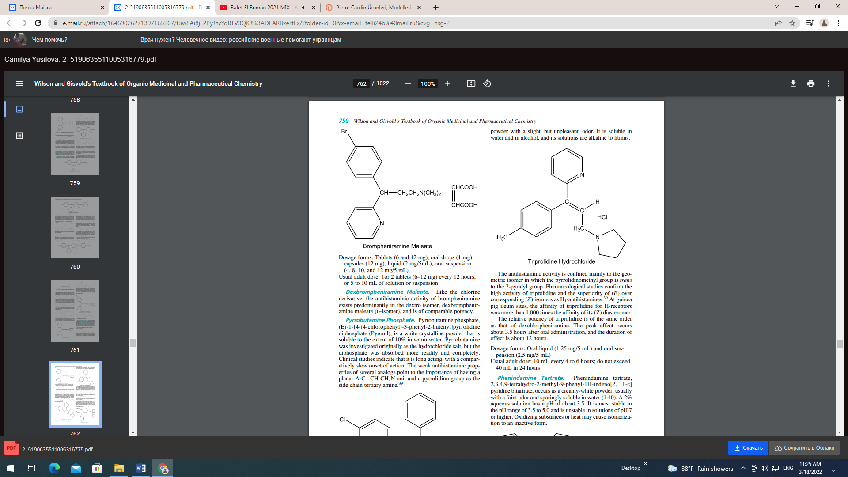
Dosage forms: Tablets (6 and 12 mg), oral drops (1 mg), capsules (12 mg), liquid (2 mg/5mL), oral suspension (4, 8, 10, and 12 mg/5 mL) Usual adult dose: 1or 2 tablets (6–12 mg) every 12 hours, or 5 to 10 mL of solution or suspension Dexbrompheniramine Maleate. Like the chlorine derivative, the antihistaminic activity of brompheniramine exists predominantly in the dextro isomer, dexbrompheniramine maleate (D-isomer), and is of comparable potency. Pyrrobutamine Phosphate. Pyrrobutamine phosphate, (E)-1-[4-(4-chlorophenyl)-3-phenyl-2-butenyl]pyrrolidine diphosphate (Pyronil), is a white crystalline powder that is soluble to the extent of 10% in warm water. Pyrrobutamine was investigated originally as the hydrochloride salt, but the diphosphate was absorbed more readily and completely. Clinical studies indicate that it is long acting, with a comparatively slow onset of action. The weak antihistaminic properties of several analogs point to the importance of having a planar ArCCH-CH2N unit and a pyrrolidino group as the side chain tertiary amine.
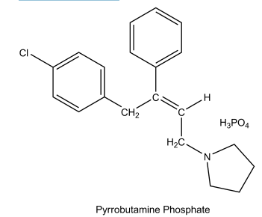
Triprolidine Hydrochloride. Triprolidine hydrochloride, (E)-2-[3-(1-pyrrolidinyl)-1-p-tolylpropenyl]pyridine monohydrochloride monohydrate (Actidil), is a white crystalline powder with a slight, but unpleasant, odor. It is soluble in water and in alcohol, and its solutions are alkaline to litmus.
The antihistaminic activity is confined mainly to the geometric isomer in which the pyrrolidinomethyl group is trans to the 2-pyridyl group. Pharmacological studies confirm the high activity of triprolidine and the superiority of (E) over corresponding (Z) isomers as H1-antihistamines.39 At guinea pig ileum sites, the affinity of triprolidine for H-receptors was more than 1,000 times the affinity of its (Z) diasteromer. The relative potency of triprolidine is of the same order as that of dexchlorpheniramine. The peak effect occurs about 3.5 hours after oral administration, and the duration of effect is about 12 hours. Dosage forms: Oral liquid (1.25 mg/5 mL) and oral suspension (2.5 mg/5 mL) Usual adult dose: 10 mL every 4 to 6 hours; do not exceed 40 mL in 24 hours Phenindamine Tartrate. Phenindamine tartrate, 2,3,4,9-tetrahydro-2-methyl-9-phenyl-1H-indeno[2, 1-c] pyridine bitartrate, occurs as a creamy-white powder, usually with a faint odor and sparingly soluble in water (1:40). A 2% aqueous solution has a pH of about 3.5. It is most stable in the pH range of 3.5 to 5.0 and is unstable in solutions of pH 7 or higher. Oxidizing substances or heat may cause isomerization to an inactive form.
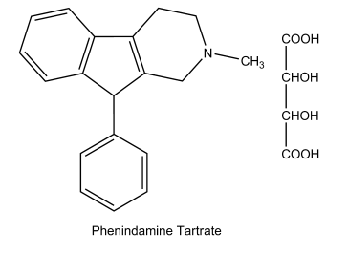
Structurally, phenindamine can be regarded as an unsaturated propylamine derivative, in that the rigid ring system contains a distorted, trans-alkene. Like the other commonly used antihistamines, it may produce drowsiness and sleepiness; it may also cause a mildly stimulating action in some patients and insomnia when taken just before bedtime. Dosage forms: Tablets (25 mg) Usual adult dose: 1 tablet every 4 to 6 hours, not to exceed 6 tablets in 24 hours Dimethindene Maleate. Dimethindene maleate,)2- [1-[2-[2-dimethylamino)ethyl]-inden-3-yl]ethyl]pyridine bimaleate (1:1) (Forhistal Maleate), is a white to off-white crystalline powder that has a characteristic odor and is sparingly soluble in water. This potent antihistaminic agent may be considered a derivative of the unsaturated propylamines. The principal side effect is some sedation or drowsiness. The antihistaminic activity resides mainly in the levorotatory isomer.
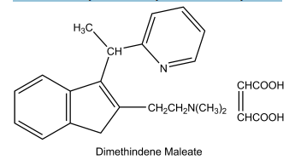
totype of this class, promethazine, have been resolved and found to possess similar antihistaminic and other pharmacological properties as described later.40,41 This is in contrast with results of studies of the pheniramines and carbinoxamine compounds in which the chiral center is closer to the aromatic moieties of the molecule. Thus, asymmetry appears to have less influence on antihistaminic activity when the chiral center lies near the positively charged side-chain nitrogen. In general, the combination of lengthening of the side chain and substitution of lipophilic groups in the 2-position of the aromatic ring results in compounds with decreased antihistaminic activity and increased psychotherapeutic properties. Also, unlike the phenothiazine antipsychotics, the heterocyclic ring of the antihistamines is unsubstituted.
Promethazine, the parent member of this series, is a moderately potent antihistamine based on pA2 values and doses with pronounced sedative effects (Table 23.2). It is a relatively long-acting antihistamine as a result of slow metabolic inactivation, perhaps because of sterically hindered cytochrome Ndealkylation. In addition to its antihistaminic and sedating action, it is a potent antiemetic, anticholinergic, and significantly potentiates the action of analgesic and other sedative drugs.30 The other members of this series display a similar pharmacological profile and thus may cause drowsiness and impair the ability to perform tasks requiring alertness. Also, concurrent administration of alcoholic beverages and other CNS depressants with the phenothiazines should be avoided.10 Although few pharmacokinetic data are available for the phenothiazine antihistamines, the metabolism of a close structural analog promethazine has been studied in detail.31 This compound undergoes mono- and di-N-dealkylation, sulfur oxidation, aromatic oxidation at the 3-position to yield the phenol, and N-oxidation. Several of these metabolites, particularly the phenol, may yield glucuronide conjugates. It is expected that the phenothiazine antihistamines would display similar metabolic profiles. Promethazine Hydrochloride. Promethazine hydrochloride,)10-[2-(dimethylamino)-propyl]phenothiazine monohydrochloride (Phenergan), occurs as a white to faint yellow crystalline powder that is very soluble in water, in hot absolute alcohol, and in chloroform. Its aqueous solutions are slightly acid to litmus. Dosage forms: Tablets (12.5, 25, and 50 mg), oral syrup (6.25 mg/5 mL), rectal suppositories (12.5, 25, and 50 mg), injection (25 and 50 mg/mL) Usual adult dose: • Allergy: 25 mg taken before retiring; however, 12.5 mg may be taken before meals or on retiring, if necessary Chapter 23 Histamine and Antihistaminic Agents 751
PHENOTHIAZINES Beginning in the mid-l940s, several antihistaminic drugs were been discovered as a result of bridging the aryl units of agents related to the ethylenediamines. The search for effective antimalarials led to the investigation of phenothiazine derivatives in which the bridging entity is sulfur. Subsequent testing found that the phenothiazine class of drugs had not only antihistaminic activity but also a pharmacological profile of its own, considerably different from that of the ethylenediamines (Fig. 23.11). Thus began the era of development of useful psychotherapeutic agents, the phenothiazine antipsychotics. The phenothiazine derivatives that display therapeutically useful antihistaminic actions contain a two- or three-carbon, branched alkyl chain between the ring system and terminal nitrogen atom. This differs significantly from the phenothiazine antipsychotic series in which an unbranched propyl chain is required. The branched alkyl chain contains a chiral carbon, giving rise to optical isomerism. The enantiomers of the pro totype of this class, promethazine, have been resolved and found to possess similar antihistaminic and other pharmacological properties as described later.
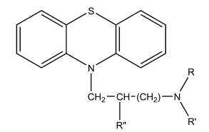
This is in contrast with results of studies of the pheniramines and carbinoxamine compounds in which the chiral center is closer to the aromatic moieties of the molecule. Thus, asymmetry appears to have less influence on antihistaminic activity when the chiral center lies near the positively charged side-chain nitrogen. In general, the combination of lengthening of the side chain and substitution of lipophilic groups in the 2-position of the aromatic ring results in compounds with decreased antihistaminic activity and increased psychotherapeutic properties. Also, unlike the phenothiazine antipsychotics, the heterocyclic ring of the antihistamines is unsubstituted. Promethazine, the parent member of this series, is a moderately potent antihistamine based on pA2 values and doses with pronounced sedative effects (Table 23.2). It is a relatively long-acting antihistamine as a result of slow metabolic inactivation, perhaps because of sterically hindered cytochrome Ndealkylation. In addition to its antihistaminic and sedating action, it is a potent antiemetic, anticholinergic, and significantly potentiates the action of analgesic and other sedative drugs.30 The other members of this series display a similar pharmacological profile and thus may cause drowsiness and impair the ability to perform tasks requiring alertness. Also, concurrent administration of alcoholic beverages and other CNS depressants with the phenothiazines should be avoided.10 Although few pharmacokinetic data are available for the phenothiazine antihistamines, the metabolism of a close structural analog promethazine has been studied in detail.31 This compound undergoes mono- and di-N-dealkylation, sulfur oxidation, aromatic oxidation at the 3-position to yield the phenol, and N-oxidation. Several of these metabolites, particularly the phenol, may yield glucuronide conjugates. It is expected that the phenothiazine antihistamines would display similar metabolic profiles. Promethazine Hydrochloride. Promethazine hydrochloride, ()10-[2-(dimethylamino)-propyl]phenothiazine monohydrochloride (Phenergan), occurs as a white to faint yellow crystalline powder that is very soluble in water, in hot absolute alcohol, and in chloroform. Its aqueous solutions are slightly acid to litmus.
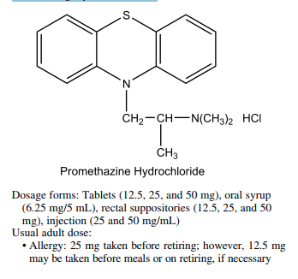
• Transfusion reactions: 25-mg doses to control minor transfusion reactions • Motion sickness: 25 mg taken 30 to 60 minutes before travel and repeated 8 to 12 hours later, if necessary • Nausea and vomiting: 12.5 to 25 mg every 4 to 6 hours as necessary • Prophylactic dosage: 25 mg every 4 to 6 hours as necessary for prophylactic dosing (given during surgery and the postoperative period) and 25 to 50 mg with analgesics postoperatively or preoperatively • Sedation: 25 to 50 mg for nighttime, presurgical, or obstetrical sedation Trimeprazine Tartrate. Trimeprazine tartrate, ()10- [3-(dimethylamino)-2-methylpropyl] phenothiazine tartrate (Temaril), occurs as a white to off-white crystalline powder that is freely soluble in water and soluble in alcohol. Its antihistaminic action is reported to be from 1.5 to 5 times that of promethazine. Clinical studies have shown it has a pronounced antipruritic action that may be unrelated to its histamine-antagonizing properties.
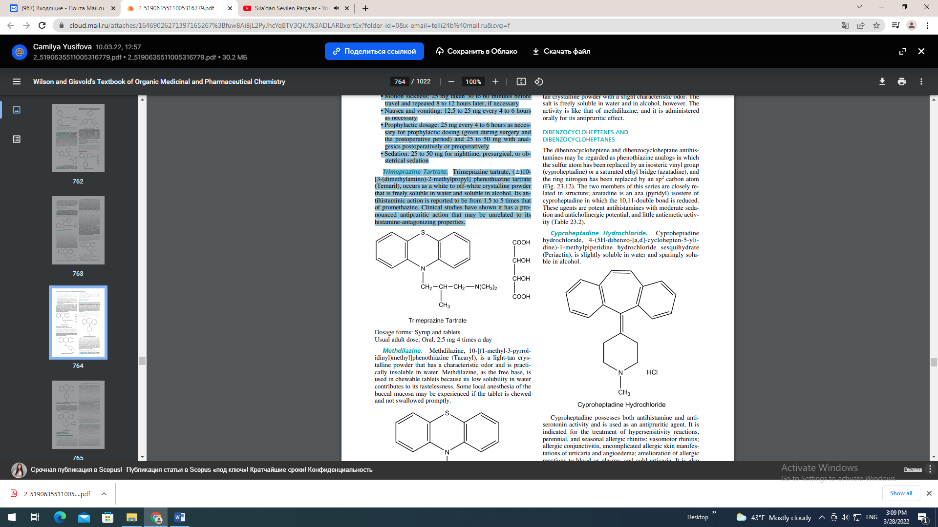
Methdilazine. Methdilazine, 10-[(1-methyl-3-pyrrolidinyl)methyl]phenothiazine (Tacaryl), is a light-tan crystalline powder that has a characteristic odor and is practically insoluble in water. Methdilazine, as the free base, is used in chewable tablets because its low solubility in water contributes to its tastelessness. Some local anesthesia of the buccal mucosa may be experienced if the tablet is chewed and not swallowed promptly. Methdilazine Hydrochloride. Methdilazine hydrochloride (Tacaryl Hydrochloride), also occurs as a lighttan crystalline powder with a slight characteristic odor. The salt is freely soluble in water and in alcohol, however. The activity is like that of methdilazine, and it is administered orally for its antipruritic effect. DIBENZOCYCLOHEPTENES AND DIBENZOCYCLOHEPTANES The dibenzocycloheptene and dibenzocycloheptane antihistamines may be regarded as phenothiazine analogs in which the sulfur atom has been replaced by an isosteric vinyl group (cyproheptadine) or a saturated ethyl bridge (azatadine), and the ring nitrogen has been replaced by an sp2 carbon atom (Fig. 23.12). The two members of this series are closely related in structure; azatadine is an aza (pyridyl) isostere of cyproheptadine in which the 10,11-double bond is reduced. These agents are potent antihistamines with moderate sedation and anticholinergic potential, and little antiemetic activity (Table 23.2). Cyproheptadine Hydrochloride. Cyproheptadine hydrochloride, 4-(5H-dibenzo-[a,d]-cyclohepten-5-ylidine)-1-methylpiperidine hydrochloride sesquihydrate (Periactin), is slightly soluble in water and sparingly soluble in alcohol.
Cyproheptadine possesses both antihistamine and antiserotonin activity and is used as an antipruritic agent. It is indicated for the treatment of hypersensitivity reactions, perennial, and seasonal allergic rhinitis; vasomotor rhinitis; allergic conjunctivitis, uncomplicated allergic skin manifestations of urticaria and angioedema; amelioration of allergic reactions to blood or plasma; and cold urticaria. It is also used off-label for nightmares associated with posttraumatic stress disorder (PTSD), prevention of migraine, suppression of vascular headaches, and appetite stimulation. Sedation is the most prominent side effect, and this is usually brief, disappearing after 3 or 4 days of treatment. Dosage forms: Tablets (4 mg) and syrup (2 mg/5 mL) Usual adult dose: Oral, 4 mg 3 or 4 times a day Azatadine Maleate. Azatadine maleate, 6,11-dihydro11-(l-methyl-4-piperidylidene)-5H-benzo-[5,6]cyclo
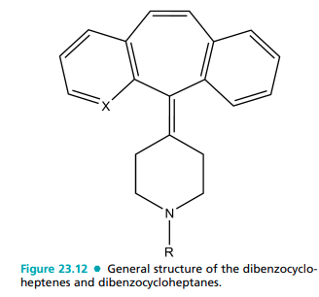
hepta(1,2-b]pyridine maleate (1:2) (Optimine), is a potent, long-acting antihistaminic with antiserotonin activity. In early testing, azatadine exhibited more than three times the potency of chiorpheniramine in the isolated guinea pig ileum screen and more than seven times the oral potency of chlorpheniramine in protection of guinea pigs against a double lethal dose of intravenously administered histamine.
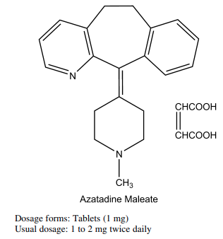
Second-Generation Antihistamines Initial design efforts toward new or second-generation antihistamines focused on developing agents with a lower sedation potential and reduced binding affinities for nontarget proteins including muscarinic, adrenergic, and serotonergic receptors. These efforts led to the introduction of astemizole and terfenadine, derivatives of the first-generation agents with substantially larger N-tertiary amine substituents (Fig. 23.13). Astemizole and terfenadine proved to be “nonsedating” and target-receptor selective, but extensive clinical use uncovered serious cardiovascular toxicities (QT prolongation and arrhythmias).10,33,34 These cardiac actions appear to result from the blockade of the rapid component of delayed rectifier potassium current (IKr) by astemizole and terfenadine, even at therapeutic concentrations. Blocking the rectifier current causes prolongation of the monophasic cardiac action potential and QT interval, as well as induction of early afterdepolarizations and dispersion (slowing) of repolarization, resulting in torsades de pointes.10 Furthermore, such cardiac effects were observed more commonly when astemizole and terfenadine were administered with other drugs that inhibit their cytochrome metabolism, such as the imidazole antifungals (ketoconazole, itraconazole) and the macrolides (erythromycin, clarithromycin). Through this drug interaction, astemizole and terfenadine levels would rise and the incidence of untoward cardiac events increases. As a result of these concerns, both astemizole and terfenadine have been withdrawn from the U.S. market. The newer second-generation H1-antihistamines described later have significantly reduced IKr current-blocking capacity, and have demonstrated significantly lower cardiotoxicity in clinical use. Further drug design efforts resulted in the discovery of new second-generation agents, which retained the nonsedating and receptor-selectivity properties, but lacked the cardiotoxicity of astemizole and terfenadine. These newer agents are structurally diverse, but are derivatives of first-generation drugs, containing larger, polar functionality connected either to the terminal tertiary amine, or as a substituent of one of the aromatic rings. The new second-generation drugs currently on the market include acrivastine, an alkene-acid derivative of triprolidine; cetirizine and levocetirizine, oxidation metabolites of hydroxyzine; desloratadine, an oxidation–hydrolysis metabolite of loratadine; and fexofenadine, an oxidative metabolite of terfenadine.10 In addition to their H1-receptor selectivity, these second-generation agents do not accumulate in the CNS because their hydrophilicity (in some cases) and high affinity for P-glycoprotein efflux pumps of cells associated with the BBB.10,42,43 The propensity of these drugs to occupy CNS H1-receptors varies from 0% for fexofenadine to 30% for cetirizine. The properties of these drugs are described in more detail in the monographs that follow.44 Fexofenadine Hydrochloride. Fexofenadine hydrochloride, ()-4-[1-hydroxy-4-[4-(hydroxyldiphenylmethyl)-1-piperinyl]butyl-,-dimethylbenzeneacetic acid (Allegra), occurs as a white to off-white crystalline powder that is freely soluble in methanol and ethanol, slightly soluble in chloroform and water, and insoluble in hexane. This compound is marketed as a racemate and exists as a zwitterion in aqueous media at physiological pH. Fexofenadine is a primary oxidative metabolite of terfenadine.45 Terfenadine was developed during a search for new butyrophenone antipsychotic drugs as evidenced by the presence of the N-phenylbutanol substituent. It also contains a diphenylmethyl-piperidine moiety analogous to that found in the piperazine antihistamines. Terfenadine is a selective, longacting (12 hours) H1-antihistamine with little affinity for muscarinic, serotonergic, or adrenergic receptors. The histamine receptor affinity of this compound is believed to be related primarily to the presence of the diphenylmethylpiperidine moiety. The prolonged action results from very slow dissociation from these receptors. The lack of anticholinergic, adrenergic, or serotonergic actions appears to be linked to the presence of the N-phenylbutanol substituent (Table 23.2). This substituent contributes to P-glycoprotein efflux pump affinity,
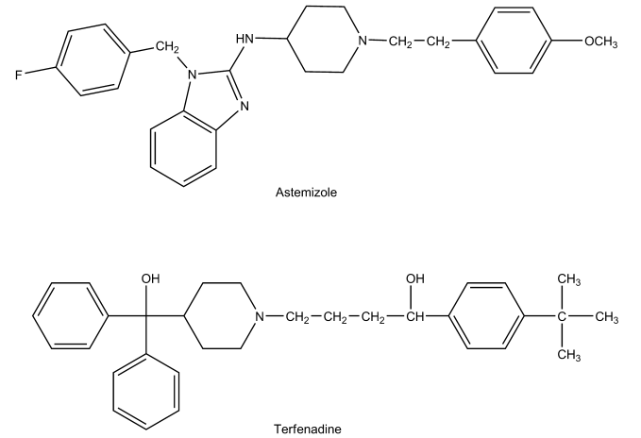
which serves to limit accumulation of terfenadine in the CNS. Terfenadine undergoes significant first-pass cytochrome P450 (CYP)-based metabolism, with the predominant metabolite being fexofenadine, an active metabolite resulting from methyl group oxidation. When drugs that inhibit this transformation, such as the imidazole antifungals and macrolides, are used concurrently, terfenadine levels may rise to toxic levels, resulting in potentially fatal heart rhythm problems that were described. The observation that fexofenadine displays antihistaminic activity comparable with that of terfenadine but is less cardiotoxic led to its development as an alternative to terfenadine for the relief of the symptoms of seasonal allergies. Fexofenadine, like terfenadine, is a selective peripheral H1-receptor ligand that produces no clinically significant anticholinergic effects or 1-adrenergic receptor blockade at therapeutic doses (Table 23.2). No sedative or other CNS effects have been reported for this drug, and animal studies indicate that fexofenadine does not cross the BBB. In vitro studies also suggest that unlike terfenadine, fexofenadine does not block potassium channels in cardiocytes. Furthermore, in drug interaction studies, no prolongation of the QTc interval or related heart rhythm abnormalities were detected when fexofenadine was administered concurrently with erythromycin or ketoconazole.10,46 Fexofenadine is indicated for the treatment of seasonal allergic rhinitis and chronic idiopathic urticaria. It is rapidly absorbed after oral administration, producing peak serum concentrations in about 2.5 hours. Fexofenadine is 60% to 70% plasma protein bound. Unlike its parent drug, only 5% of the total dose of fexofenadine is metabolized. The re
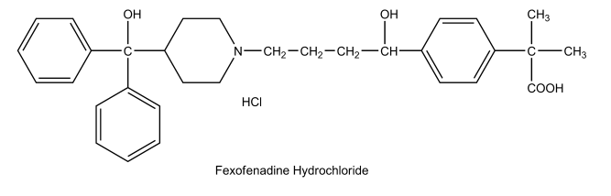
mainder is excreted primarily in the urine; the mean elimination half-life is about 14 hours (Table 23.3).10 Dosage form: Tablets (30, 60, and 180 mg), oral disintegrating tablets (30 mg), and an oral suspension (6 mg/mL) Usual doses: • Chronic idiopathic urticaria: 60 mg twice daily or 180 mg once daily in adults and children 12; lower doses are recommended in children • Seasonal allergic rhinitis: 60 mg twice daily or 180 mg once daily in adults and children 12; lower doses are recommended in children Loratadine. Loratadine, 4-(8-chloro-5, 6-dihydro- 11Hbenzo[5,6]-cyclohepta[1,2-b]pyridin-l 1-ylidene-1-carboxylic acid ethyl ester, is a white to off-white powder insoluble in water but very soluble in acetone, alcohols, and chloroform. Loratadine is structurally related to the antihistamines azatadine and cyproheptadine, and to some tricyclic antidepressants. It differs from azatadine, in that a neutral carbamate group has replaced the basic tertiary amino moiety, and a phenyl ring has been substituted with a chlorine atom. Loratadine is a selective peripheral H1-antihistamine with a receptor-binding profile like that of the other members of this series, except that it has more antiserotonergic activity (Table 23.2). Thus, it produces no substantial CNS or autonomic side effects or cardiac toxicity. Loratadine displays potency comparable with that of astemizole and greater than that of terfenadine.
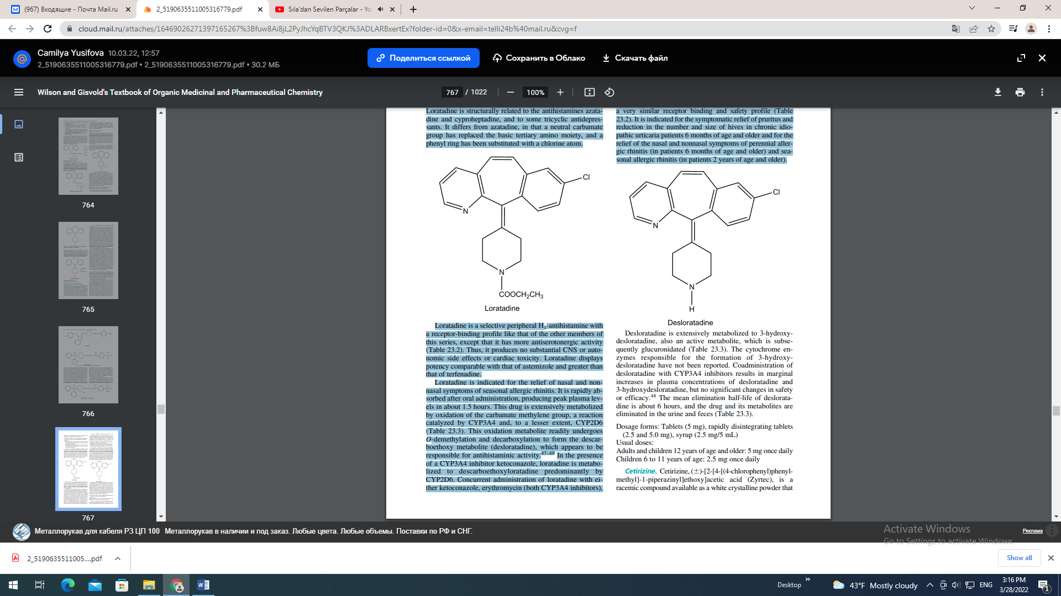
Loratadine is indicated for the relief of nasal and nonnasal symptoms of seasonal allergic rhinitis. It is rapidly absorbed after oral administration, producing peak plasma levels in about 1.5 hours. This drug is extensively metabolized by oxidation of the carbamate methylene group, a reaction catalyzed by CYP3A4 and, to a lesser extent, CYP2D6 (Table 23.3). This oxidation metabolite readily undergoes O-demethylation and decarboxylation to form the descarboethoxy metabolite (desloratadine), which appears to be responsible for antihistaminic activity.47–49 In the presence of a CYP3A4 inhibitor ketoconazole, loratadine is metabolized to descarboethoxyloratadine predominantly by CYP2D6. Concurrent administration of loratadine with either ketoconazole, erythromycin (both CYP3A4 inhibitors), or cimetidine (CYP2D6 and CYP3A4 inhibitor) is associated with substantially increased plasma concentrations of loratadine.10,48 Both parent drug and active metabolite have elimination half-lives ranging from 8 to 15 hours. The metabolite is excreted renally as a conjugate (Table 23.3).10 Dosage forms: Tablets (5 and 10 mg), oral disintegrating tablets (5 and 10 mg), syrup (5 mg/5 mL) Usual adult dose (allergic rhinitis): 10 mg once daily (adults and children 6 years of age and older), 5 mg (chewable tablets, syrup) once daily for children 2 to 5 years of age Desloratadine. Desloratadine, 8-chloro-6,11-dihydro11-(4-piperdinylidene)-5H-benzo[5,6]cyclohepta[1,2-b]pyridine (Clarinex) is a white to off-white powder that is slightly soluble in water, but very soluble in ethanol and propylene glycol. It is the proposed active metabolite loratadine and has a very similar receptor binding and safety profile (Table 23.2). It is indicated for the symptomatic relief of pruritus and reduction in the number and size of hives in chronic idiopathic urticaria patients 6 months of age and older and for the relief of the nasal and nonnasal symptoms of perennial allergic rhinitis (in patients 6 months of age and older) and seasonal allergic rhinitis (in patients 2 years of age and older).

Desloratadine is extensively metabolized to 3-hydroxydesloratadine, also an active metabolite, which is subsequently glucuronidated (Table 23.3). The cytochrome enzymes responsible for the formation of 3-hydroxydesloratadine have not been reported. Coadministration of desloratadine with CYP3A4 inhibitors results in marginal increases in plasma concentrations of desloratadine and 3-hydroxydesloratadine, but no significant changes in safety or efficacy.48 The mean elimination half-life of desloratadine is about 6 hours, and the drug and its metabolites are eliminated in the urine and feces (Table 23.3). Dosage forms: Tablets (5 mg), rapidly disintegrating tablets (2.5 and 5.0 mg), syrup (2.5 mg/5 mL) Usual doses: Adults and children 12 years of age and older: 5 mg once daily Children 6 to 11 years of age: 2.5 mg once daily Cetirizine. Cetirizine, ()-[2-[4-[(4-chlorophenyl)phenylmethyl]-1-piperazinyl]ethoxy]acetic acid (Zyrtec), is a racemic compound available as a white crystalline powder that is water soluble.
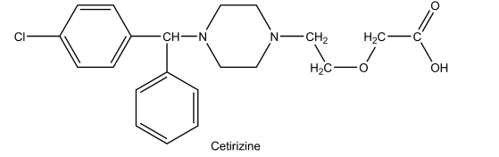
Cetirizine is the primary acid metabolite of hydroxyzine, resulting from complete oxidation of the primary alcohol moiety. This compound is zwitterionic and relatively polar and thus does not penetrate or accumulate in the CNS.10,50,51 Before its introduction in the United States, cetirizine was one of the most widely prescribed H1-antihistamines in Europe. It is highly selective in its interaction with various neuronal binding sites and highly potent ( terfenadine) as well (Table 23.2). The advantages of this compound appear to be its long action (once-daily dosing), rapid onset of activity, minimal CNS effects and a lack of clinically significant effects on cardiac rhythm.10,50 Cetirizine produces qualitatively different effects on psychomotor and psychophysical functions from the firstgeneration antihistamines.10,50 The drug has been associated with dose-related somnolence, however, so patients should be advised that cetirizine may interfere with the performance of certain jobs or activities. Other effects of this drug include fatigue, dry mouth, pharyngitis, and dizziness. Because the drug is extensively eliminated by a renal route, its adverse reactions may be more pronounced in individuals suffering from renal insufficiency. No cardiotoxic effects, such as QT prolongation, are observed with the new drug when used at its recommended or higher doses or when coadministered with imidazole antifungals and macrolide antibiotics.10 Other typical drug interactions of H1-antihistamines, however, apply to cetirizine and concurrent use of this drug with alcohol and other CNS depressants should be avoided. Cetirizine is indicated for the temporary relief of runny nose, sneezing, itching of the nose or throat, and/or itchy, watery eyes caused by hay fever or other upper respiratory allergies. It also relieves itching caused by hives (urticaria), but it will not prevent hives or an allergic skin reaction from occurring. Dose-proportional Cmax values are achieved within 1 hour of oral administration of cetirizine. Food slows the rate of cetirizine absorption but does not affect the overall extent. Consistent with the polar nature of this carboxylic acid drug, less than 10% of peak plasma levels have been measured in the brain. Cetirizine is not extensively metabolized, and more than 60% of a 10-mg oral dose is excreted in the urine (60% as unchanged drug) and 10% is recovered in the feces (Table 23.3). The drug is highly protein bound (93%) and has a terminal half-life of 8.3 hours. The clearance of cetirizine is reduced in elderly subjects and in renally and hepatically impaired patients. Dosage forms: Tablets (5 and 10 mg) and oral syrup (1 mg/mL) Usual adult dose (allergies/hay fever and urticaria): 5 to 10 mg once daily depending on the severity of symptoms, up to maximum of 10 mg/day in adults and children 6 or older; 2.5 mg once daily of the oral solution for children younger than the age of 6 Levocetirizine Dihydrochloride. Levocetirizine dihydrochloride, (R)-[2-[4-[(4-chlorophenyl) phenylmethyl]-1- piperazinyl] ethoxy] acetic acid dihydrochloride, (Xyzal) is a white, crystalline powder and is water soluble. This R-enantiomer is has a 30-fold higher affinity than the S-enantiomer, and dissociates more slowly from H1-receptors.51 Pharmacologically, it displays the same receptor and CNS selecitivity profile as the racemate, cetirizine (Table 23.2), and thus the same therapeutic advantages. Levocetirizine is indicated for the relief of symptoms associated with allergic rhinitis (seasonal and perennial) in adults and children 6 years of age and older and for the treatment of the uncomplicated skin manifestations of chronic idiopathic urticaria in adults and children 6 years of age and older. Its pharmacokinetics and clearance profile are essentially the same as the racemate, cetirizine (Table 23.3). Dosage forms: Tablets (5 mg) and solution (2.5 mg/5 mL) Usual dose: 5 mg (one tablet or 10-mL oral solution) once daily in the evening for adults and children 12 years of age and older; 2.5 mg (half of a tablet or 5-mL oral solution) once daily in the evening for children 6 to 11 years old Acrivastine. Acrivastine, (E, E)-3-[6-[1-(4-methylphenyl)- 3-(1-pyrrolidinyl)-1-propenyl-2-pyridinyl]-2-propenoic acid (Semprex), is a fixed-combination product of the antihistamine acrivastine (8 mg) with the decongestant pseudoephedrine (60 mg). Acrivastine is an odorless, white to pale cream crystalline powder that is soluble in chloroform and alcohol and slightly soluble in water.
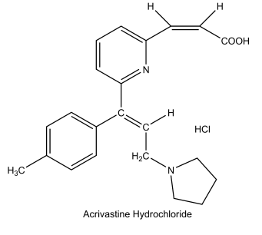
Acrivastine is an analog of triprolidine containing a carboxyethenyl moiety at the 6-position of the pyridyl ring. Acrivastine shows antihistaminic potency and duration of action comparable to those of triprolidine (Table 23.2). Unlike triprolidine, acrivastine does not display significant anticholinergic activity at therapeutic concentrations. Also, the enhanced polarity of this compound resulting from carboxyethenyl substitution limits BBB accumulation, and thus, this compound produces less sedation than triprolidine. Limited pharmacokinetic data are available for this compound. Orally administered drug has a half-life of about 1.7 hours and a total body clearance of 4.4 mL/min per kilogram. The mean peak plasma concentrations are reported to vary widely, and the drug appears to penetrate the CNS poorly. The metabolic fate of acrivastine has not been reported. Dosage forms: Tablets: various combination products Usual adult dose: Oral, 8 or 60 mg 3 to 4 times a day
INHIBITION OF HISTAMINE RELEASE:
MAST CELL STABILIZERS The discovery of the bronchodilating activity of the natural product khellin, obtained from the plant Ammi visnaga, led to the development of the bis(chromones) as compounds that stabilize mast cells and inhibit the release of histamine and other mediators of inflammation.52 The first therapeutically significant member of this class was cromolyn sodium. Further research targeting more effective agents resulted in the introduction of nedocromil, followed more recently by pemirolast and lodoxantide. Generally, the mast cell stabilizers inhibit activation of, and mediator release from, various inflammatory cell types associated with allergy and asthma, including eosinophils, neutrophils, macrophages; mast cells, monocytes, and platelets. In addition to histamine, these drugs inhibit the release of leukotrienes (C4, D4, E4) and prostaglandins.53,54 In vitro studies suggest that these drugs stimulate the protein kinase C-mediated phosphorylation of moesin. This phosphorylated protein then binds with key proteins on the secretory granule (such as actin) and stabilizes them to prevent exocytosis. Other studies suggest that the bischromones indirectly inhibit calcium ion entry into the mast cell and that this action prevents mediator release.
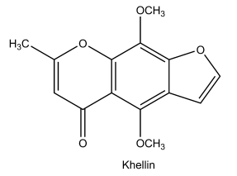
In addition to their inhibition of mediator release, some of these drugs also inhibit the chemotaxis of eosinophils at the site of application (i.e., ocular tissue).54 In lung tissue, pretreatment with the mast cell stabilizers cromolyn and nedocromil blocks the immediate and delayed bronchoconstrictive reactions induced by the inhalation of antigens. These drugs also attenuate the bronchospasm associated with exercise, cold air, environmental pollutants, and certain drugs (aspirin). However, the mast cell stabilizers do not have intrinsic bronchodilator, antihistamine, anticholinergic, vasoconstrictor, or glucocorticoid activity, and, when delivered by inhalation at the recommended dose, have no known therapeutic systemic activity. The structures, chemical properties, pharmacological profiles, and dosage data for these agents are provided in the monographs that follow. Cromolyn Sodium. Cromolyn sodium, disodium 1,3- bis(2-carboxychromon-5-yloxy)-2-hydroxypropane (Intal), is a hygroscopic, white, hydrated crystalline powder that is soluble in water (1:10). It is tasteless at first but leaves a very slightly bitter aftertaste. The pK of cromolyn is 2. It is available as a solution for a nebulizer, an aerosol spray, a nasal solution, an ophthalmic solution, and an oral concentrate. Nebulized and aerosol cromolyn has been used for prophylactic management of bronchial asthma and prevention of exercise-induced bronchospasm.52 Cromolyn nasal solution is used for the prevention and treatment of allergic rhinitis, and oral concentrate is used to treat the histaminic symptoms of mastocytosis (diarrhea, flushing, headaches, vomiting, urticaria, abdominal pain, nausea, and itching). Topical cromolyn (eye drops) is used to treat allergic conjunctivitis and keratitis. In the treatment of asthma, cromolyn efficacy is manifested by decreased severity of clinical symptoms, or need for
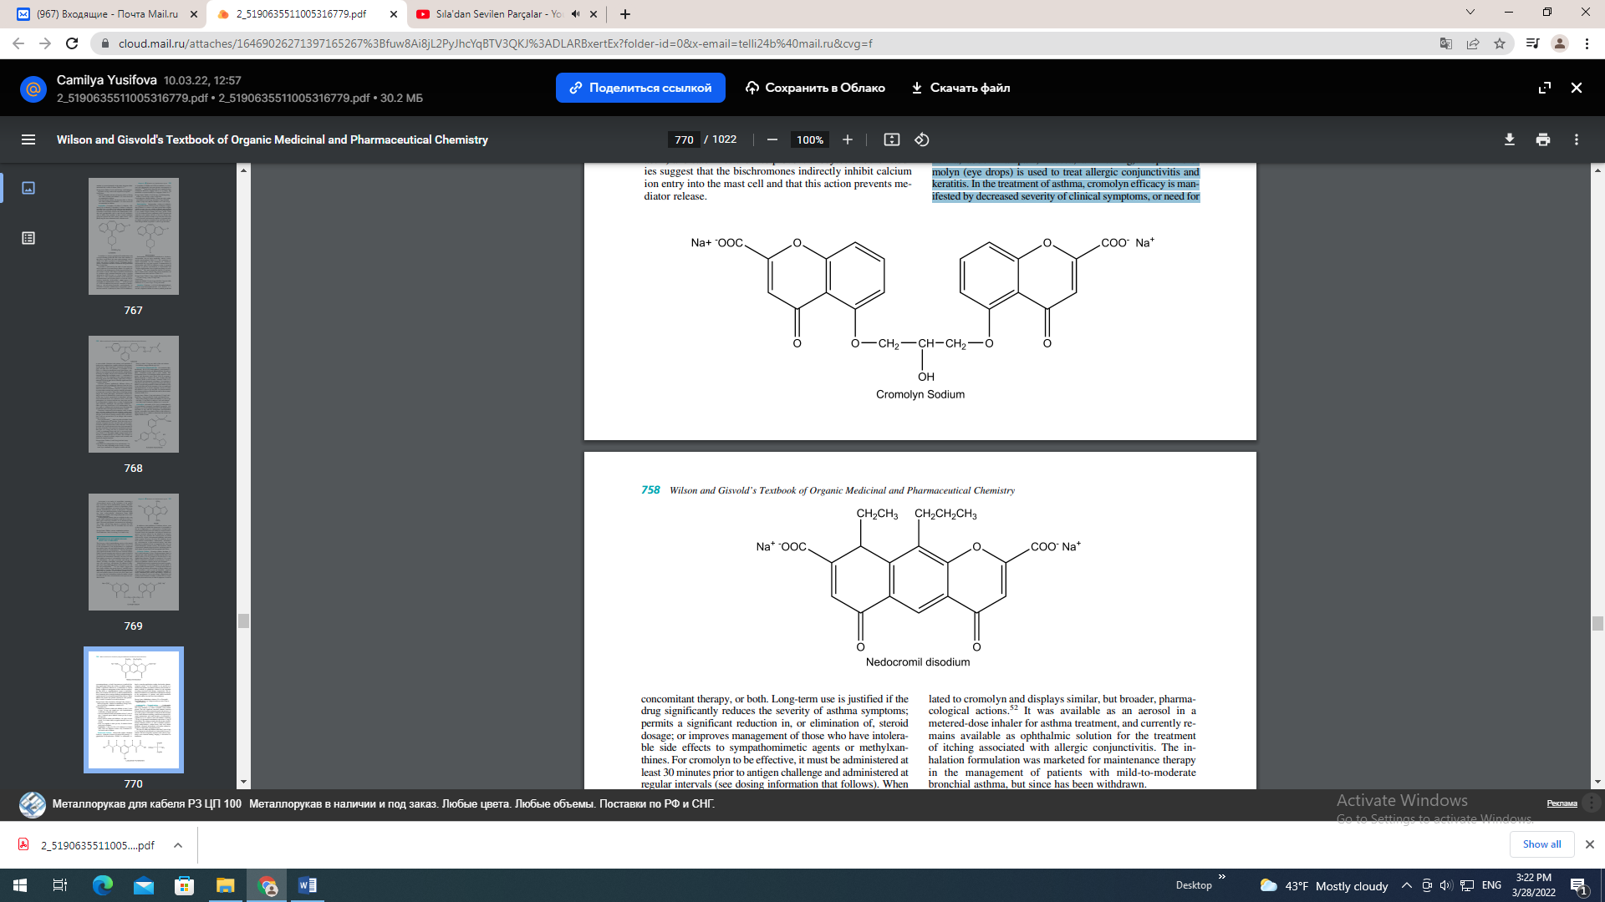
concomitant therapy, or both. Long-term use is justified if the drug significantly reduces the severity of asthma symptoms; permits a significant reduction in, or elimination of, steroid dosage; or improves management of those who have intolerable side effects to sympathomimetic agents or methylxanthines. For cromolyn to be effective, it must be administered at least 30 minutes prior to antigen challenge and administered at regular intervals (see dosing information that follows). When inhaled, the powder does produce irritation in some patients. Also, overuse of cromolyn can result in tolerance. Dosage forms: Oral concentrate (100 mg/5 mL), nasal solution (40 mg/mL), solution for inhalation (20 mg/2 mL), aerosol (800 mg), ophthalmic solution (4%) Usual adult dose: • Inhalation solution (adults and children at least 2 years of age): 20 mg (one ampule per vial) bynebulization 4 times/day at regular intervals • Aerosol (asthma in adults and children at least 5 years of age): 2 metered sprays inhaled 4 times per day at regular intervals • Nasal solution (adults and children): one spray in each nostril 3 to 6 times daily at regular intervals every 4 to 6 hours • Oral: two ampules 4 times per day 30 minutes before meals and at bedtime • Ophthalmic: 1 drop of a 2% to 4% solution 4 to 6 times daily; Oral: two ampules 4 times a day 30 minutes before meals and at bedtime Nedocromil Sodium. Nedocromil sodium, disodium 9-ethyl-6, 9-dihydro-4,6-dioxo-10-propyl-4H-pyrano[3, 2- g]quinoline-2,8-dicarboxylate (Tilade), is structurally related to cromolyn and displays similar, but broader, pharmacological actions.52 It was available as an aerosol in a metered-dose inhaler for asthma treatment, and currently remains available as ophthalmic solution for the treatment of itching associated with allergic conjunctivitis. The inhalation formulation was marketed for maintenance therapy in the management of patients with mild-to-moderate bronchial asthma, but since has been withdrawn. Dosage forms: Ophthalmic solution (2% or 20 mg/mL) Usual adult dose: 1 or 2 drops in each eye twice a day at regular intervals Lodoxamide Tromethamine. Lodoxamide tromethamine, N, N-(2-chloro-5-cyano-m-phenylene)dioxamic acid (Alomide), is a white crystalline, water-soluble powder. The only significant structural similarity between lodoxamide and cromolyn and nedocromil is the presence of two acidic groups. Lodoxamide is indicated in the treatment of the ocular disorders including vernal keratoconjunctivitis, vernal conjunctivitis, and vernal keratitis.55 Lodoxamide is available as a 0.1% solution, with each milliliter containing 1.78 mg of lodoxamide tromethamine equivalent to 1 mg of lodoxamide. The solution contains the preservative benzalkonium chloride (0.007%) as well as mannitol, hydroxypropyl methylcellulose, sodium citrate, citric acid, edetate disodium, tyloxapol, hydrochloric acid and/or sodium hydroxide (to adjust pH), and purified water. The dose for adults and children older than 2 years of age is 1 to 2 drops in each affected eye 4 times daily for up to 3 months. The most frequently reported ocular adverse experiences were transient burning, stinging, or discomfort on instillation.
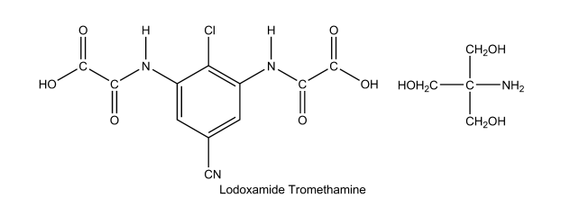
Pemirolast Potassium Ophthalmic Solution. Pemirolast potassium, 9-methyl-3-(1H-tetrazol-5-yl)-4Hpyrido[1, 2-]pyrimidin-4-one potassium (Alamast), is a yellow, water-soluble powder. It can be considered an analog of one portion of the cromolyn structure in which the carboxyl group has been replaced with an isosteric tetrazole moiety. Pemirolast is indicated for the prevention of itching of the eye caused by allergic conjunctivitis. The commercial preparation is available as a 0.1% sterile ophthalmic solution for topical administration to the eyes. Each milliliter of this solution contains 1 mg of pemirolast potassium, as well as the preservative lauralkonium chloride (0.005%), and glycerin, phosphate buffers, and sodium hydroxide to maintain a solution pH of 8.0. The solution has an osmolality of 240 mOsm/L. The recommended dose is 1 to 2 drops instilled into each affected eye 4 times a day. This drug product is for ocular administration only and not for injection or oral use and should be used with caution during pregnancy or while nursing.
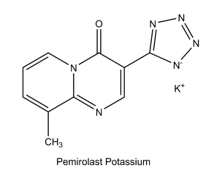
Over the several past decades, there has been considerable interest in the development of novel antihistaminic compounds with dual mechanisms of action including H1-receptor antihistaminic action and mast cell stabilization. Currently available drugs that exhibit such dual antihistaminic actions include azelastine and ketotifen. These compounds contain the basic pharmacophore to produce relatively selective antihistaminic action (diarylalkylamines) as well as inhibition of the release of histamine and other mediators (e.g., leukotrienes and PAP) from mast cells involved in the allergic response. In vitro studies suggest that these compounds also decrease chemotaxis and activation of eosinophils. Azelastine and ketotifen currently are indicated for the treatment of itching of the eye associated with allergic conjunctivitis. Their antiallergy actions occur within minutes after administration and may persist for up to 8 hours. The structures, chemical properties, pharmacological profiles, and dosage data for these agents are provided in the monographs that follow. Azelastine Hydrochloride Ophthalmic Solution. Azelastine hydrochloride, ()-4-[(4-chlorophenyl) methyl]-2-(hexahydro-l-methyl-1H-azepin-4-yl)-l-(2H)- phthalazinone monohydrochloride (Optivar), is a white crystalline powder that is sparingly soluble in water, methanol, and propylene glycol and slightly soluble in ethanol, octanol, and glycerine. The commercial preparation is available as a 0.05% sterile ophthalmic solution for topical administration to the eyes. Each milliliter of azelastine solution contains 0.5-mg azelastine hydrochloride equivalent to 0.457 mg of azelastine base, the preservative benzalkonium chloride (0.125 mg), and inactive ingredients including disodium edetate dihydrate, hydroxypropylmethylcellulose, sorbitol solution, sodium hydroxide, and water for injection. The solution has a pH of approximately 5.0 to 6.5 and an osmolality of approximately 271 to 312 mOsm/L.
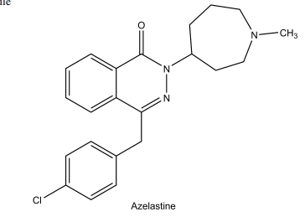
The recommended dose of azelastine solution is 1 drop instilled into each affected eye twice a day. This drug product is for ocular administration only and not for injection or oral use. Absorption of azelastine following ocular administration is relatively low (less than 1 ng/rnL). Absorbed drug undergoes extensive oxidative N-demethylation by CYP, and the parent drug and metabolite are eliminated primarily in the feces. The most frequently reported adverse reactions are transient eye burning or stinging, headaches, and bitter taste. Azelastine solution should be used with caution during pregnancy or while nursing, because its safety has not been studied under these circumstances.57 Ketotifen Fumarate Ophthalmic Solution. Ketotifen fumarate, 4-(1-methyl-4-piperidylidene)-4Hbenzo[4,5]cyclohepta[1,2-b]thiophen-10(9H)-one hydrogen fumarate (Zaditor), is a fine crystalline powder. Ketotifen is a ketothiophene isostere analog of the dibenzocycloheptane antihistamines. The solution contains 0.345 mg of ketotifen fumarate, which is equivalent to 0.25 mg of ketotifen. The solution also contains the preservative benzalkonium chloride (0.01%) as well as glycerol, sodium hydroxide and/or hydrochloric acid (to adjust pH), and purified water. It has a pH of 4.4 to 5.8 and an osmolality of 210 to 300 mOsm/kg
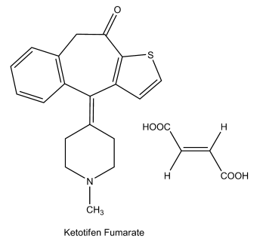
The recommended dose of ketotifen solution is 1 drop instilled into each affected eye every 8 to 12 hours. The most frequently reported adverse reactions are conjunctival infection, headaches, and rhinitis. This drug product is for ocular administration only and not for injection or oral use. Ketotifen solution should be used with caution during pregnancy or while nursing, because its safety has not been studied under these circumstances.58 HISTAMINE H2-ANTAGONISTS Drugs whose pharmacological action primarily involves antagonism of the action of histamine at its H2-receptors find therapeutic application in the treatment of acid-peptic disorders including heartburn, gastroesophageal reflux disease (GERD), erosive esophagitis, gastric and duodenal ulcers, and gastric acid pathologic hypersecretory diseases such as Zollinger-Ellison syndrome. They are also useful in combination with H1-antihistamines for the treatment of chronic urticaria and for the itching of anaphylaxis and pruritis.59–62 Gastric Acid Secretion A characteristic feature of the mammalian stomach is its ability to secrete acid as part of its processes to digest food for absorption later in the intestine. The presence of acid and proteolytic pepsin enzymes, whose formation is facilitated by the low gastric pH, is generally assumed to be required for the hydrolysis of proteins and other food constiuents. The acid secretory unit of the gastric mucosa is the parietal (oxyntic) cell. Parietal cells contain an H, K-ATPase or hydrogen ion pump that secretes proton (H) in exchange for the uptake of K ion (Fig, 23.14).61,62 Secretion of acid by gastric parietal cells is stimulated by various mediators at receptors located on the basolateral membrane, including histamine agonism of H2-receptors (cellular), gastrin activity at G receptors (blood), and acetylcholine (ACh) at M2 muscarinic receptors (neuronal). Gastric and muscarinic receptors modulate acid secretion through calcium-dependent processes, while the H2-receptor is coupled to adenylate cyclase (Fig. 23.14). The adenylate cyclase pathway, and therefore acid secretion, is inhibited by intracellular prostaglandins of the E series. These prostaglandins also stimulate other GI epithelial cells to secrete mucous and bicarbonate, and enhance blood flow through gastric tissues. All of these prostaglandin-mediated actions have acidneutralizing and gastric tissue protective properties referred to generally as “cytoprotection.” When there is hypersecretion of gastric acid or breakdown of muscosal cell defenses, including bacterial infection, gastric tissues and contiguous structures (esophagus, intestines) may become compromised and ulcerated.61,62 Peptic Ulcer Disease Peptide ulcer disease (PUD) is a group of upper GI tract disorders characterized by mucosal erosions equal to or greater than 0.5 cm that result from the erosive action of acid and pepsin.63 Duodenal ulcer and gastric ulcer are the most common forms, although PUD may occur in the esophagus or small intestine. Factors involved in the pathogenesis and recurrence of PUD include hypersecretion of acid and pepsin and GI infection by Helicobacter pylori, a Gram-negative spiral bacterium. H. pylori have been found in virtually all patients with duodenal ulcers and approximately 75% of patients with gastric ulcers. Some risk factors associated with recurrence of PUD include cigarette smoking, chronic use of ulcerogenic drugs (e.g., nonsteroidal anti-inflammatory drugs [NSAIDs]), male gender, age, alcohol consumption, emotional stress, and family history. About 4% of gastric ulcers are caused by a malignancy, whereas duodenal ulcers are generally benign. The goals of PUD therapy are to promote healing, relieve pain, and prevent ulcer complications and recurrences. Medications used to heal or reduce ulcer recurrence include antacids, histamine H2-antagonists, protective mucosal barriers, proton pump inhibitors (PPIs), prostaglandins, and bismuth salt and combinations of these drugs with antibiotics to eradicate H. pylori infection. Structural Derivation of the “H2-Antagonists” The H2-antagonists are used to treat acid indigestion (an OTC application), GERD, peptic ulcers, and pathologic hypersecretory disorders, as well as some of the symptoms of urticaria and anaphylaxis. Cimetidine, the original member of this drug class, was developed by a classical structure– activity study beginning with the endogenous agonist, histamine as shown in Table 23.4.64 Methylation of the 5-position of the imidazole heterocycle of histamine produced a selective agonist at atrial histamine receptors (H2). The guanidino analog of histamine was then found to possess weak antagonist activity to the acid-secretory actions of histamine. Increasing the length of the side chain from two to four carbons, coupled with replacement of the strongly basic guanidino group by a neutral methyl thiourea function, led to development of burimamide, the first full H2-receptor antagonist, albeit one of low potency. The low potency of burimamide was postulated to be related to its nonbasic, electron-releasing side chain, which favors the nonpharmacophoric NMH imidazole tautomer over the basic, electronwithdrawing side chain in histamine, which predominantly presents the higher-affinity N MH imidazole tautomer to the
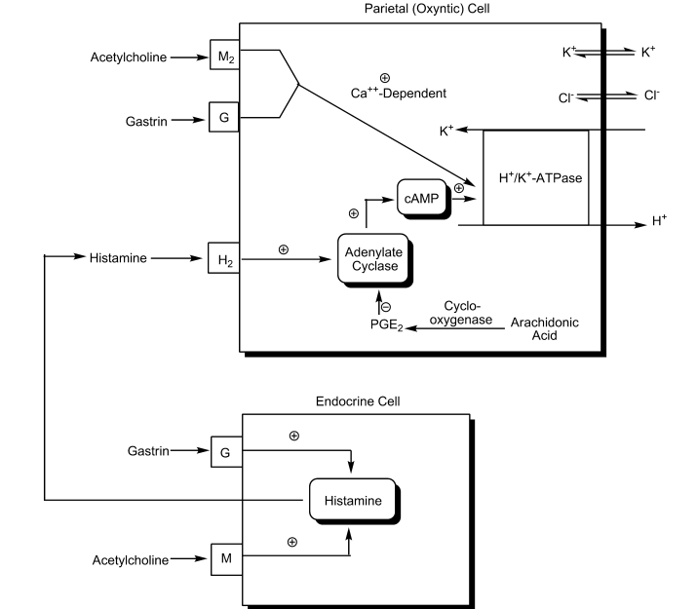
receptor. Insertion of an electronegative thioether function in the side chain in place of a methylene group favors the N MH tautomer, and introduction of the 5-methyl group favors H2 selectivity and led to metiamide, an H2-blocker of higher potency and oral bioavailability than burimamide. Unfortunately, drug-related toxicities including agranulocytosis prevented further development of this compound. However, replacement of the thiourea moiety of metiamide with a cyano-imino function produced cimetidine, the first clinically effective and relatively safe member of this therapeutic class (Table 23.4).64 Introduction of cimetidine into medicine revealed an effective gastric antisecretory agent that promotes the healing of duodenal ulcers. Cimetidine is not without several limitations, however. Because it is short acting, it requires a frequentdosing schedule. Also, cimetidine was found to possess antiandrogenic activity, which can lead to gynecomastia, and to cause confusional states in some elderly patients and decreased renal function. Also, cimetidine inhibits CYP isozymes and renal tubular secretion, resulting in clinically significant drug interactions.65 The drug interaction potential and several adverse effects (gynecomastia) of cimetidine appear to be directly related to the presence of the imidazole group. These limitations prompted additional drug design and development efforts, which revealed that the imidazole ring was not required for H2-antagonist activity (discussed next). In fact, replacement of the imidazole ring with a furan (raniditine) or a thiazole (famotidine, nizatidine) heterocycle with a basic ring substitutent (guanidine or dimethylaminomethyl) not only enhances both potency and selectivity of H2-antagonism, but also reduces cytochrome and renal secretory drug interactions.64 The pharmacokinetic properties of the H2-antagonists are summarized in Table 23.5.66 Cimetidine, ranitidine, and
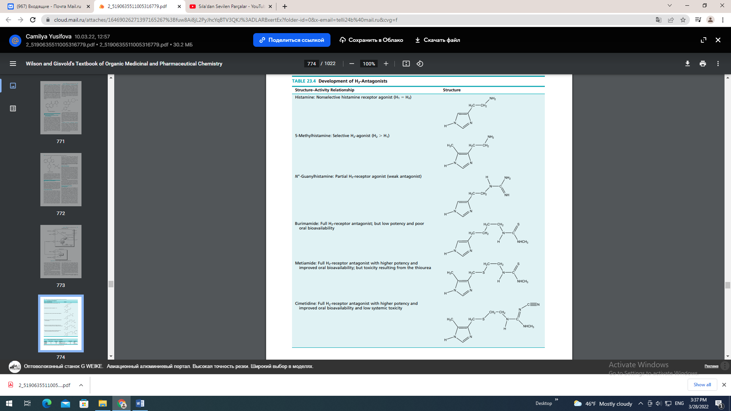
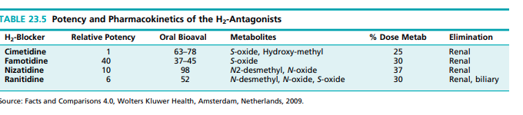
famotidine have lower oral bioavailabilities than nizatidine as a result of greater first-pass metabolism. Based on their common structural features, most of these agents are metabolized by S- and N-oxidation. The imidazole ring of cimetidine serves as an addition site for oxidative metabolism, as do the N,N-dimethyl functionalities of nizatidine and ranitidine. All of these metabolites are presumed to be inactive, or at least less active than the parent drugs. Also, a significant proportion of the dose of each of the H2-antagonists is excreted renally in unmetabolized form. The half-lives of these agents range from 1 to 4 hours, with nizatidine having the shortest half-life.66 The properties of the individual H2- antagonists that are in clinical use in the United States are described and compared in the monographs that follow. Cimetidine, USP. Cimetidine, N-cyano-N-methyl-N- [2-[[5-methylimidazol-4-yl)methyl]thio]ethyl]guanidine (Tagamet), is a colorless crystalline solid that is slightly soluble in water (1.14% at 37°C). The solubility is greatly increased by the addition of dilute acid to protonate the imidazole ring (apparent pKa of 6.8). At pH 7, aqueous solutions are stable for at least 7 days. Cimetidine is a relatively hydrophilic molecule with an octanol/water partition coefficient of 2.5. Cimetidine inhibits the hepatic metabolism of drugs biotransformed by various CYP isozymes, delaying elimination and increasing serum levels of these drugs. Thus, concomitant therapy with cimetidine and drugs metabolized by hepatic cytochrome isozymes or in patients with renal or hepatic impairment may require dosage adjustment. This is particulary true for drugs with relatively low therapeutic indices including warfarin-type anticoagulants, phenytoin, propranolol, nifedipine, benzodiazepines, certain tricyclic antidepressants, lidocaine, theophylline, and metronidazole.66 Additionally, cimetidine administration may increase gastric pH and decrease the absorption of drugs such as the azole antifungals (e.g., ketoconazole), which require an acidic environment for dissolution.66 If concurrent azole therapy is required, it is best to administer it at least 2 hours before cimetidine administration. Cimetidine has a weak antiandrogenic effect, and it may cause gynecomastia in patients treated for 1 month or more. Cimetidine exhibits relatively good bioavailability (60%– 70%) and a plasma half-life of about 2 hours, which is increased in renal and hepatic impairment and in the elderly. Approximately 30% to 40% of a cimetidine dose is metabolized (S-oxidation, 5-CH3 hydroxylation), and the parent drug and metabolites are eliminated primarily by renal excretion.66 Antacids interfer with cimetidine absorption and should be administered at least 1 hour before or after a cimetidine dose. Dosage forms: Tablet (200, 300, 400, 800 mg), liquid (300 mg/5 mL), injection (150/mL and 6 mg/mL) Usual adult oral dose: • Benign gastric ulcer: 800 or 300 mg 4 times a day • Duodenal ulcer: 800 or 300 mg 4 times a day (with meals and at bedtime); maintenance dose, 400 mg 4 times a day • Gastroesophageal reflux disease, erosive: 1,600 mg daily in divided doses (800 mg twice daily or 400 mg 4 times per day) for 12 weeks • Heartburn relief or prevention (OTC): 200 mg with water as symptoms occur or right before or any time up to 30 minutes before eating food or drinking; maximum dosage, 400 mg/day • Pathological hypersecretory conditions: 300 mg 4 times per day with meals and at bedtime; maximum dosage, 2,400 mg/day • Usual pediatric dose: Oral, 20 to 40 mg (base) per kilogram of body weight 4 times a day with meals and at bedtime Famotidine, USP. Famotidine, N-(aminosulfonyl)-3- [[[2[(diamnomethylene)amino]-4-thiazolyl]methyl] thio]propanimidamide (Pepcid), is a white to pale-yellow crystalline compound that is very slightly soluble in water and practically insoluble in ethanol. It is a thiazole bioisotere of cimetidine that contains a guanidine substituent that may mimic the imizadole of cimetidine. Famotidine is a competitive inhibitor of histamine H2- receptors with a potency significantly greater than cimetidine. It inhibits basal and nocturnal gastric secretion as well as secretion stimulated by food and pentagastrin. Its current labeling indications are for the short-term treatment of duodenal and benign gastric ulcers, GERD, pathological hypersecretory conditions (e.g., Zollinger-Ellison syndrome), and heartburn (OTC only).66 No cases of gynecomastia, increased prolactin levels, or impotence have been reported, even at the higher dosage levels used in patients with pathological hypersecretory conditions. Studies with famotidine in humans, in animal models, and in vitro have shown no significant interference with the disposition of compounds metabolized by cytochrome isozymes. No significant interactions have been detected with warfarin, theophylline, phenytoin, diazepam, aminopyrine, and antipyrine. Famotidine is incompletely absorbed (37%–45% bioavailability). The drug is eliminated by renal (65%– 70%) and metabolic (30%–35%) routes. Famotidine sulfoxide is the only metabolite identified in humans. The effects of food or antacid on the bioavailability of famotidine are not clinically significant.
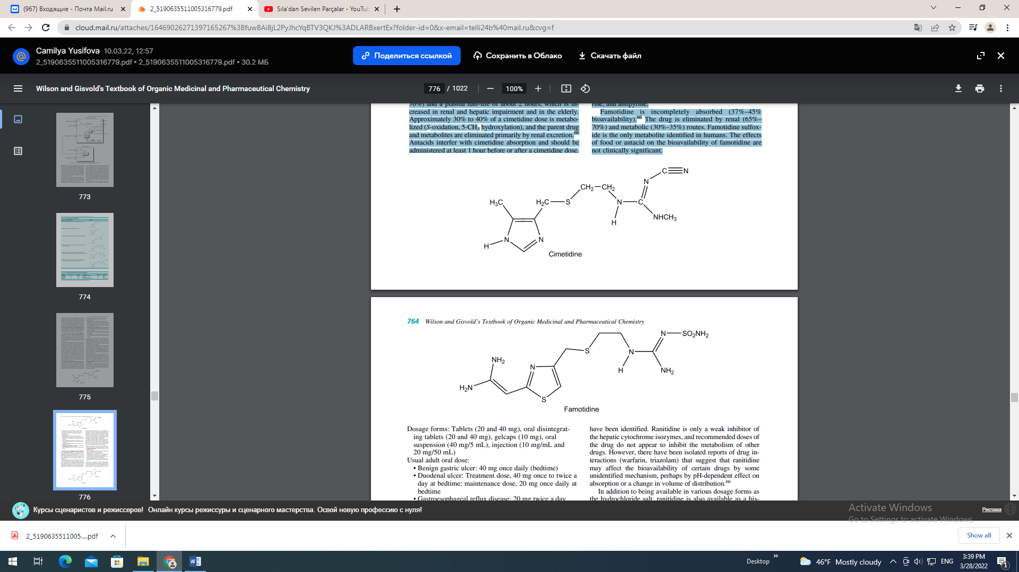

Dosage forms: Tablets (20 and 40 mg), oral disintegrating tablets (20 and 40 mg), gelcaps (10 mg), oral suspension (40 mg/5 mL), injection (10 mg/mL and 20 mg/50 mL) Usual adult oral dose: • Benign gastric ulcer: 40 mg once daily (bedtime) • Duodenal ulcer: Treatment dose, 40 mg once to twice a day at bedtime; maintenance dose, 20 mg once daily at bedtime • Gastroesophageal reflux disease: 20 mg twice a day • Heartburn: 10 to 20 mg for relief or 1 hour before a meal for prevention • Esophagitis, including erosions and ulcerations: 20 or 40 mg twice a day • Pathological hypersecretory conditions: individualize dosage; typically 20 mg every 6 hours • Severe Zollinger-Ellison syndrome: up to 160 mg every 6 hours Ranitidine, USP. Ranitidine, N-[2-[[[5-(dimethylamino)methyl]-2-furanyl]methyl]thiol] ethyl]-N-methyl-2- nitro-l,1-ethenediamine (Zantac), is a white solid, which in its hydrochloride salt form is highly soluble in water. It is an aminoalkyl furan derivative with pKa values of 2.7 (side chain) and 8.2 (dimethylamino). Ranitidine is more potent than cimetidine, but less potent than famotidine. Like other H2-antagonists, it does not appear to bind to other receptors.66 Bioavailability of an oral dose of ranitidine is about 50% and is not significantly affected by the presence of food.66 Some antacids may reduce ranitidine absorption and should not be taken within 1 hour of administration of this drug. The plasma half-life of the drug is 2 to 3 hours, and it is excreted along with its metabolites in the urine. Three metabolites, ranitidine N-oxide, ranitidine S-oxide, and desmethyl ranitidine, have been identified. Ranitidine is only a weak inhibitor of the hepatic cytochrome isozymes, and recommended doses of the drug do not appear to inhibit the metabolism of other drugs. However, there have been isolated reports of drug interactions (warfarin, triazolam) that suggest that ranitidine may affect the bioavailability of certain drugs by some unidentified mechanism, perhaps by pH-dependent effect on absorption or a change in volume of distribution.66 In addition to being available in various dosage forms as the hydrochloride salt, ranitidine is also available as a bismuth citrate salt for use with the macrolide antibiotic clarithromycin in treating patients with an active duodenal ulcer associated with H. pylori infection. Eradication of H. pylori reduces the risk of duodenal ulcer recurrence. Dosage forms: Tablets (75, 150, and 300 mg of HCI salt); effervescent tablets (25 and 150 mg); capsules (150 and 300 mg); syrup (15 mg/mL as HCI salt); injection (1 and 25 mg/mL as HCI salt) Usual adult oral dose: • Erosive esophagitis: 150 mg 4 times daily initially and then 150 mg twice daily for maintenance • Benign gastric ulcer: 150 mg twice a day • Duodenal ulcer: 150 mg twice a day or 300 mg daily initially and then 150 mg once daily for maintenance • Heartburn (OTC only): Initial dosage for relief 1 tablet, can be used up to twice daily for maintenance • Gastroesophageal reflux disease: 150 mg twice a day • Pathological hypersecretory conditions: 150 mg twice a day Nizatidine. Nizatidine, N-[2-[[[2-(dimethylamino) methyl]-4-thiazolyl]methyl]thio]-ethyl]-N-methyl-2-nitro1,1-ethenediamine (Axid), is an off-white to buff crystalline solid that is soluble in water, alcohol, and chloroform. It is a thaizole derivative of raniditine and has pKas of 2.1 (side chain) and 6.8 (dimethylamino).
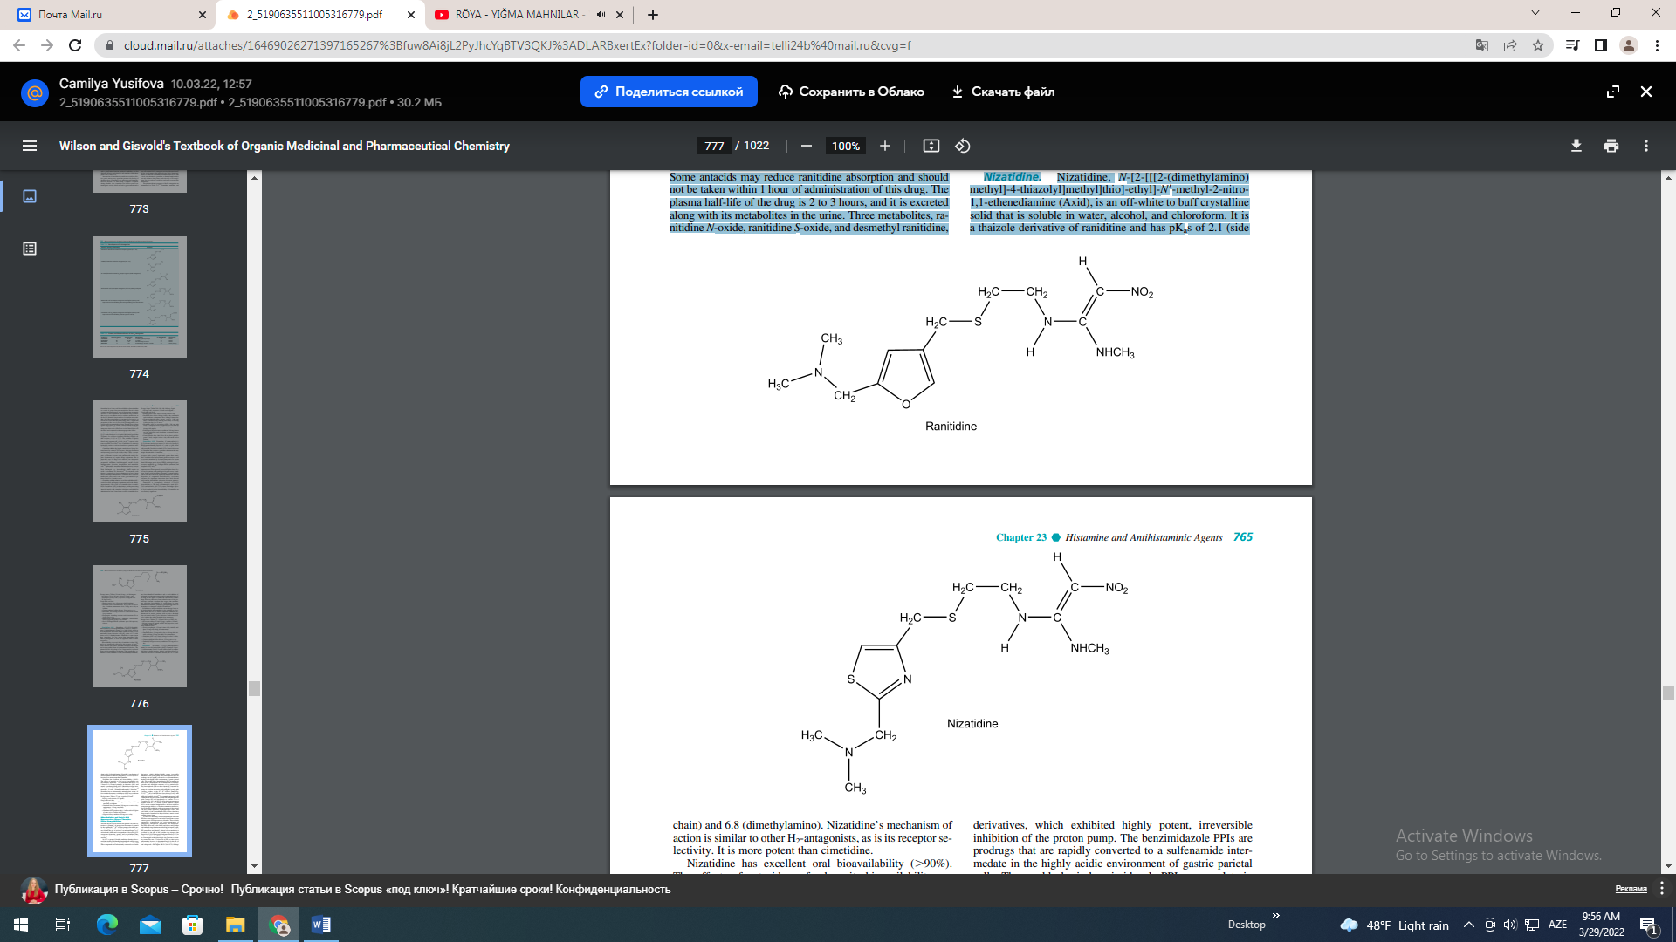

Nizatidine’s mechanism of action is similar to other H2-antagonists, as is its receptor selectivity. It is more potent than cimetidine. Nizatidine has excellent oral bioavailability (90%). The effects of antacids or food on its bioavailability are not clinically significant.66 The elimination half-life is 1 to 2 hours. It is excreted primarily in the urine (90%) and mostly as unchanged drug (60%). Metabolites include nizatidine sulfoxide (6%), N-desmethylnizatidine (7%), and nizatidine N-oxide (dimethylaminomethyl function).66 Nizatidine has no demonstrable antiandrogenic action, effects on other hormones, or inhibitory effects on cytochrome isozymes involved in the metabolism of other drugs. Dosage forms: Tablets (75 mg), capsules (150 and 300 mg), oral solution (15 mg/mL) Usual adult oral dose: • Benign gastric ulcer: 150 mg twice a day or 300 mg once daily at bedtime. • Duodenal ulcer: Treatment, 300 mg once to twice a day; maintenance, 150 mg once daily • GERD: 150 mg twice a day • Heartburn (OTC products only): 1 tablet with a full glass of water, up to 2 tablets in 24 hours. • Hypersecretory condition: 150 mg twice a day Other Antiulcer and Gastric Acid Hypersecretory Disease Therapies: Proton Pump Inhibitors The final step in acid secretion in the parietal cell is the extrusion or “pumping” of protons into the lumen of stomach by the membrane H, K-ATPase pump as described previously (Fig. 23.14). Thus, inhibition of this proton pump acts beyond the site of action of second messengers (e.g., calcium and cAMP) and is independent of the action of secretogogues histamine, gastrin, and acetyicholine. Thus, acid pump inhibitors block both basal and stimulated acid secretion. In 1972, a group of Swedish medicinal chemists discovered that certain pyridylmethyl benzimidazole sulfides were capable of functioning as H, K-ATPase or PPIs.67,68 These compounds were subsequently converted to sulfoxide derivatives, which exhibited highly potent, irreversible inhibition of the proton pump. The benzimidazole PPIs are prodrugs that are rapidly converted to a sulfenamide intermedate in the highly acidic environment of gastric parietal cells. The weakly basic benzimidazole PPIs accumulate in these acidic compartments on the luminal side of the tubuvesicular and canalicular structures of the parietal cells. The benzimidazole PPIs are then chemically converted by acid to a sulfenamide intermediate that inhibits the proton pump via covalent interaction with sulfhydryl groups with cysteine residues of the H, K-ATPase pump (Fig. 23.15).67,68 All of the PPIs have been shown to react with cysteine 813 of pump, but some bind to additional pump sulfhydryl residues as well.69 For example, omeprazole and esomeprazole also react with cysteine 892, and pantoprazole with cysteine 822 and lansoprazole to cysteine 321.69,70 Cysteines 321, 813, and 822 are all in the proton-transport domain of the H, K-ATPase system, whereas cysteine 892 is on the external luminal surface and does not affect pump transport ability.69,70 The bioaccumulation and activation of the PPIs within the acidic environment of the parietal cell also ensures specificity of pharmacologic action. The acid lability of the benzimidazole PPIs dictates that these drugs must be formulated as delayed-release, enteric-coated granular dosage forms. To date, five structually related benzimidazole sulfoxide PPIs have been approved for use in the United States to treat various gastric acid hypersecretory disorders. These include omeprazole, esomeprazole (the active enantiomers of omeprazole), lansoprazole, patoprazole, and rabeprazole. The PPIs differ only in the nature and degree and pyridine and imidazole ring substituents, which has an impact on pKa values and pharmacokinetic properties. The extent of initial PPI protonation and, thereby, parietal cell accumulation is governed by the pKa of the pyridine ring nitrogen that ranges from 3.8 for lansoprazole and pantoprazole to 4.5 for rabeprazole (Table 23.6).71 Thus, all drugs are believed to be concentrated at their physiologic site of action to a similar extent. The rate of conversion of PPIs to their active sulfenamides, however, is determined largely by the pKa of the benzimidazole group (pKa2). Omeprazole, lansoprazole, and rabeprazole with higher pKa2s (0.62–0.79) undergo benzimidazole protonation and sulfenamide formation faster than pantoprazole with a pKa2 of 0.11.
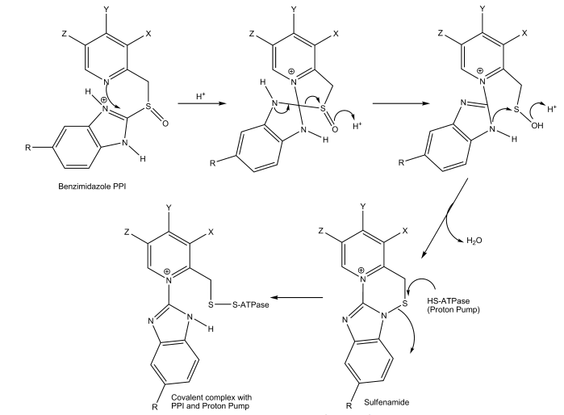
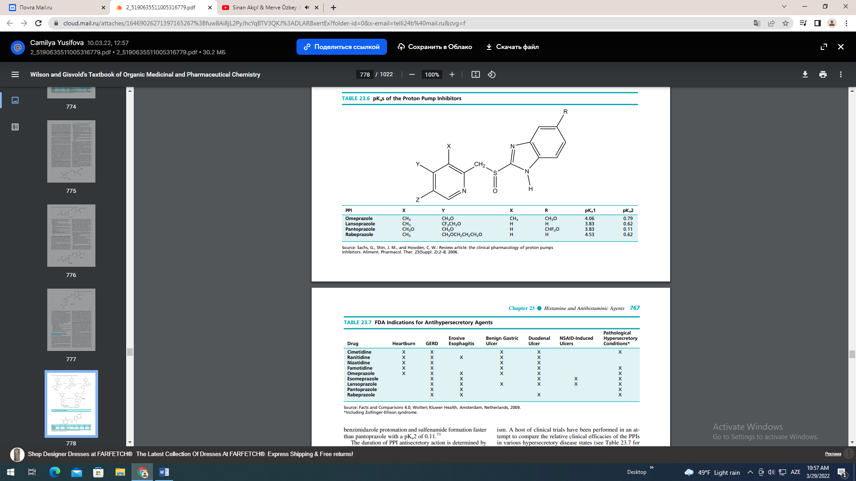
The duration of PPI antisecretory action is determined by several factors including the extent and nature of cysteine residues inactivated, pump protein turnover, activation of inactive pumps, and reactivation of inhibited pumps by endogenous reducing agents capable of breaking the PPI-pump disulfide bonds.72–74 PPIs that inactivate cysteine 822 (pantoprazole) tend to have the longest duration of effect, because this cyteine residue is on the pump transport domain, is resistant to reductive reactivation, and therefore, requires replacement by new pump protein. Thus, pantoprazole has an effective half-life of 46 hours, whereas omeprazole is 28 hours, and lansoprazole is less than 15 hours.72–75 The significance of the differences in rates of PPI activation or duration of action does not appear to have overwhelming clinical significance. Most clinical data suggests that these PPIs are more effective in the short term than the H2-blockers in healing duodenal ulcers and erosive esophagitis and can even heal esophagitis resistant to treatment with the H2-antagonists.73,74 In addition, the benzimidazole PPIs are reported to have antimicrobial activity against H. pylori, and thus, possess efficacy in treating gastric ulcers or with one or more antimicrobials, in eradicating infection by this organism. A host of clinical trials have been performed in an attempt to compare the relative clinical efficacies of the PPIs in various hypersecretory disease states (see Table 23.7 for indications). Often the results of these studies have been difficult to interpret because of many variables in PPI formulation, dosage strength, pharmacokinetic properties, diagnostic criteria, etc. Most studies have concluded, however, that comparable dosage strengths and formulations of all of these agents are therapeutically interchangeable in terms of clinical efficacy.73,74 The PPIs also share a very similar adverse reaction profile, with the most common adverse effects involving abdominal pain, diarrhea, and headache. Several other, more severe, adverse reactions (serious allergy, blood dyscrasias) have been reported rarely with PPI use, but have not been linked causally with the drugs.73,74 The PPIs vary in their oral bioavialability from 30% (omeprazole) to 80% (lansoprazole), and bioavailability generally increases upon repeated dosing. All, except rabeprazole, achieve peak plasma levels by about 2 hours (Table 23.8).66 All of PPIs are eliminated almost entirely as cytochrome-based metabolites and, with the exception of lansoprazole, predominantly by the renal route. Virtually no unchanged drug is excreted in the urine and feces. The cytochrome isozymes primarily involved in PPI metabolism in clude CYP2C19 and CYP3A4, and these catalyze pyridine ring methyl oxidation (CYP2C19: omeprazole, esomeprazole), benzimidazole ring O-demethylation (CYP2C19: omeprazole and esomeprazole) and sulfoxide oxidation (all PPIs as illustrated in Fig. 23.16) for omeprazole.
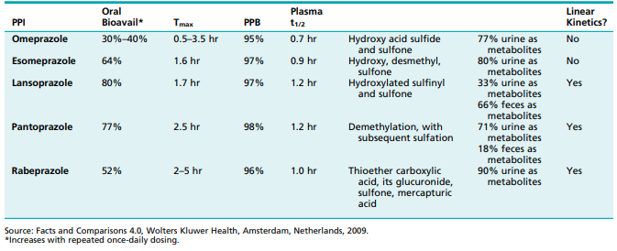
The primary metabolite of omeprazole, a racemate, is 5-hydroxymethylomeprazole, whereas the main metabolite formed from esomeprazole (the S-isomer) is the sulfone.75,76 Lansoprazole, pantoprazole, and rabeprazole lack the pyridyl 5-methyl group and benzimidazole 5-methoxy group, so they do not undergo these oxidative processes (see structures that follow).75,76 As a result of their metabolic clearance profiles, the PPIs, and especially omeprazole, can interact with other drugs that are also processed by CYP2C19 and CYP3A4 isozymes (Table 23.9). Inhibition of oxidative metabolism by omeprazole (but not esomeprazole) is responsible for prolonging the clearance of benzodiazepines, phenytoin, and warfarin.66 Lansoprazole decreases theophylline concentration slightly and may decrease the efficacy of oral contraceptives. Pantoprazole and rabeprazole appear to be free of these interactions. Further, the profound and long-lasting inhibition of gastric acid secretion by the PPIs may interfere with the bioavailability of drugs when gastric pH is an important determinant, such as the azole antifungals (e.g., ketoconazole), ampicillin, iron salts, digoxin, and cyanocobalamin (Table 23.9).66 Omeprazole. Omeprazole, 5-methoxy-2-(((4- methoxy-3, 5-dimethyl-2-pyridinyl)methyl) sulfinyl)-1Hbenzimidazole (Losec), is a white to off-white crystalline powder with very slight solubility in water. Omeprazole is an amphoteric compound (pyridine N, pKa 4.06; benzimidazole N-H, pKa 0.79), and consistent with the proposed mechanism of action of the substituted benzimidazoles, is acid labile. Hence, the omeprazole product is formulated as delayed-release capsules containing enteric-coated granules. The absolute bioavailability of orally administered orneprazole is 30% to 40% related to substantial first-pass biotransformation (Table 23.8).66 The drug has a plasma half-life of about 1 hour. Most (77%) of an oral dose of omeprazole is excreted in the urine as metabolites with insignificant antisecretory activity. The primary metabolites of omeprazole are 5-hydroxyomeprazole (CYP2C19) and omeprazole sulfone (CYP3A4). The antisecretory actions of omeprazole persist for 24 to 72 hours, long after the drug has disappeared from plasma, which is consistent with its suggested mechanism of action involving irreversible inhibition of the proton pump.
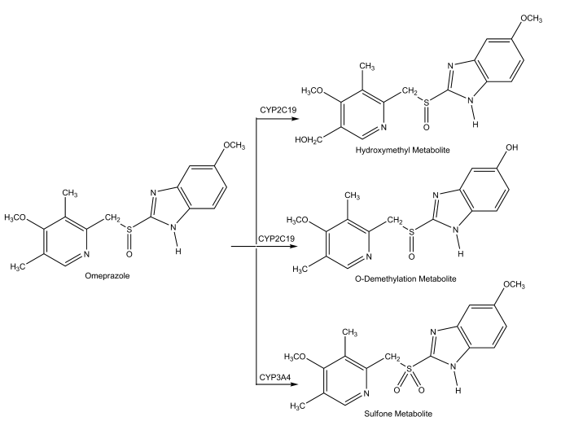
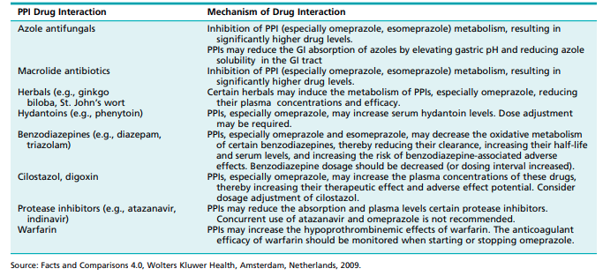
Omeprazole is approved for the treatment of heartburn, GERD, duodenal ulcer, erosive esophagitis, gastric ulcer, and pathological hypersecretory conditions. Dosage form: Delayed-release tablets (20 mg) and capsules (20 and 40 mg) Usual adult doses: • Heartburn (OTC): 20 mg daily for 14 days • GERD without esophageal lesions: 20 mg/daily for up to 4 weeks • GERD with erosive esophagitis: 20 mg/daily for 4 to 8 weeks; an additional 4 weeks of treatment may be beneficial • Duodenal ulcer: 20 mg/day for 4 or more weeks • Duodenal ulcer associated with H. pylori: Triple therapy with omeprazole 20 mg plus clarithromycin 500 mg plus amoxicillin 1,000 mg, each twice daily for 10 days. If an ulcer is present at the initiation of therapy, continue omeprazole 20 mg for an additional 14 days. • Erosive esophagitis: 20 mg daily for 4 to 8 weeks; not beyond 12 months • Gastric ulcer: 40 mg once a day for 4 to 8 weeks • Pathological hypersecretory conditions: 60 mg daily for as long as indicated; dosages up to 120 mg 3 times per day have been administered. Esomeprazole Magnesium. Esomeprazole magnesium, S-bis(5-rnethoxy-2-[(S)-[(4-methoxy-3,5-dimethyl2-pyridinyl)methyl]sulfinyl]-1H-benzimidazole-l-yl) magnesium trihydrate (Nexium), is the S-enantiomer of omeprazole. The benzimidazole PPIs contain a chiral sulfur atom that form an enantiomeric pair that is stable and insoluble under standard conditions. The S-isomer of omeprazole has slightly greater PPI activity, and its intrinsic clearance is approximately three times lower than that of R-omeprazole (15 vs. 43 L/min). The lower clearance of S-omeprazole is related to slower metabolic clearance by the CYP2C19 isozyme.66,76 Although Romeprazole is primarily transformed to the 5-hydroxy metabolite, the S-isomer is metabolized by O-demethylation and sulfoxidation, which contribute little to intrinsic clearance.
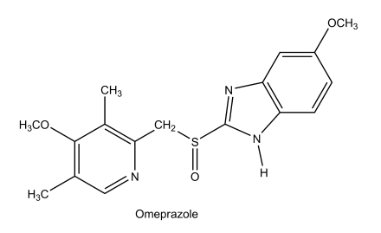
Dosage forms: Delayed-release capsules (20 or 40 mg), powder for suspension (10, 20, and 40 mg), and powder for injection (20 and 40 mg) Usual adult doses: • Symptomatic gastroesophageal reflux disease: 20 mg daily usually for 4 weeks • Erosive esophagitis: 20 or 40 mg daily usually for 4 to 8 weeks • Duodenal ulcer associated H. pylori eradication: Triple therapy with esomeprazole (40 mg once daily), amoxicillin (1,000 mg twice daily), and clarithromycin (500 mg twice daily), each for 10 days • Risk reduction of NSAIDs-associated gastric ulcer: 20 or 40 mg daily for up to 6 months • Pathological hypersecretory conditions, including Zollinger-Ellison syndrome: 40 mg twice daily but doses of up to 240 mg daily have been used Lansoprazole. Lansoprazole, 2-[[[3-methyl-4-(2,2,2- trifluoroethoxy)-2-pyridyl]methyl]sulfinyl]-1H-benzimidazole (Prevacid), is a white to brownish white, odorless crystalline powder that is practically insoluble in water. Lansoprazole is a weak base (pyridine N, pKa 3.83.) and a weak acid (benzimidazole N-H, pK 0.62). Like other PPIs, lansoprazole is essentially a prodrug that, in the acidic biophase of the parietal cell, forms an active metabolite that irreversibly interacts with the target ATPase of the pump. Lansoprazole must be formulated as encapsulated entericcoated granules for oral administration to protect the drug from the acidic environment of the stomach. In the fasting state, about 80% of a dose of lansoprazole (vs. 50% of omeprazole) reaches the systemic circulation, where it is 97% bound to plasma proteins (Table 23.8).66 The drug is metabolized in the liver (sulfone and hydroxy metabolites) and excreted in bile and urine, with a plasma half-life of about 1.5 hours. Dosage form: Delayed-release and orally disintegrating tablets (15 and 30 mg), delayed-release capsules (5 and 30 mg), delayed-release granules for oral suspension (15 and 30 mg), and a powder for injection (30 mg/vial) Usual adult dose: • GERD: 15 mg once daily for up to 8 weeks • Erosive esophagitis: Initially 30 mg once daily for up to 8 weeks. For adults who do not heal within 8 weeks (5%–10%), an additional 8 weeks of treatment may be given. Then, 15 mg once daily to maintain healing of erosive esophagitis. • Gastric ulcer: 30 mg once daily for up to 8 weeks • Gastric associated with NSAIDs: 30 mg once daily for up to 8 weeks to promote healing 15 mg once daily for up to 12 weeks to reduce the risk of NSAID-induced ulcer. Controlled studies did not extend beyond indicated duration. • Duodenal ulcer: Short-term treatment: 15 mg once daily for 4 weeks for short-term treatment and 15 mg once daily to maintain healing of duodenal ulcers • Duodenal ulcer associated with H. pylori: Dual therapy with lansoprazole (30 mg) and amoxicillin (1 g) both taken 3 times/day (every 8 hours) for 14 days for patients intolerant or resistant to clarithromycin • Duodenal ulcer associated with H. pylori: Triple therapy with lansoprazole (30 mg) plus clarithromycin (500 mg) and amoxicillin (1 g), all taken twice daily (every 12 hours) for 10 or 14 days • Hypersecretory conditions, including Zollinger-Ellison syndrome: Usually an initial dose of 60 mg once daily; dosages up to 90 mg twice daily have been administered Pantoprazole Sodium. Pantoprazole sodium, racemicsodium 5-(difluoromethoxy)-2-[[3,4-dimethoxy-2-pyridinyl) methyl]sulfinyl]-1H-benzimidazole sesquihydrate is a white to off-white crystalline powder that is freely soluble in water, very slightly soluble in phosphate buffer at pH 7.4, and practically insoluble in n-hexane. The benzimidazole of this drug has a weakly basic nitrogen (pyridine N, pKa 3.83) and an benzimidazole proton (pKa 0.11), facilitating formulation as a sodium salt. The stability of the compound in aqueous solution is pH dependent; the rate of degradation increases with decreasing pH. At ambient temperature, the degradation half-life is approximately 2.8 hours at pH 5.0 and approximately 220 hours at pH 7.8. The absorption of pantoprazole is rapid (Cmax of 2.5 g/mL, Tmax 2.5 hours) after single or multiple oral 40-mg doses. Pantoprazole is well absorbed (77% bioavailability). Administration with food may delay its absorption but does not alter pantoprazole bioavailability. Pantoprazole is distributed mainly in extracellular fluid. The serum protein binding of pantoprazole is about 98%, primarily to albumin. Pantoprazole is extensively metabolized in the liver through the CYP system, including O-demethylation (CYP2C19), with subsequent sulfation. Other metabolic pathways include sulfur oxidation by CYP3A4 (Table 23.8).66 There is no evidence that any of the pantoprazole metabolites have significant pharmacological activity. Approximately 71% of a dose of pantoprazole is excreted in the urine, with 18% excreted in the feces through biliary excretion.
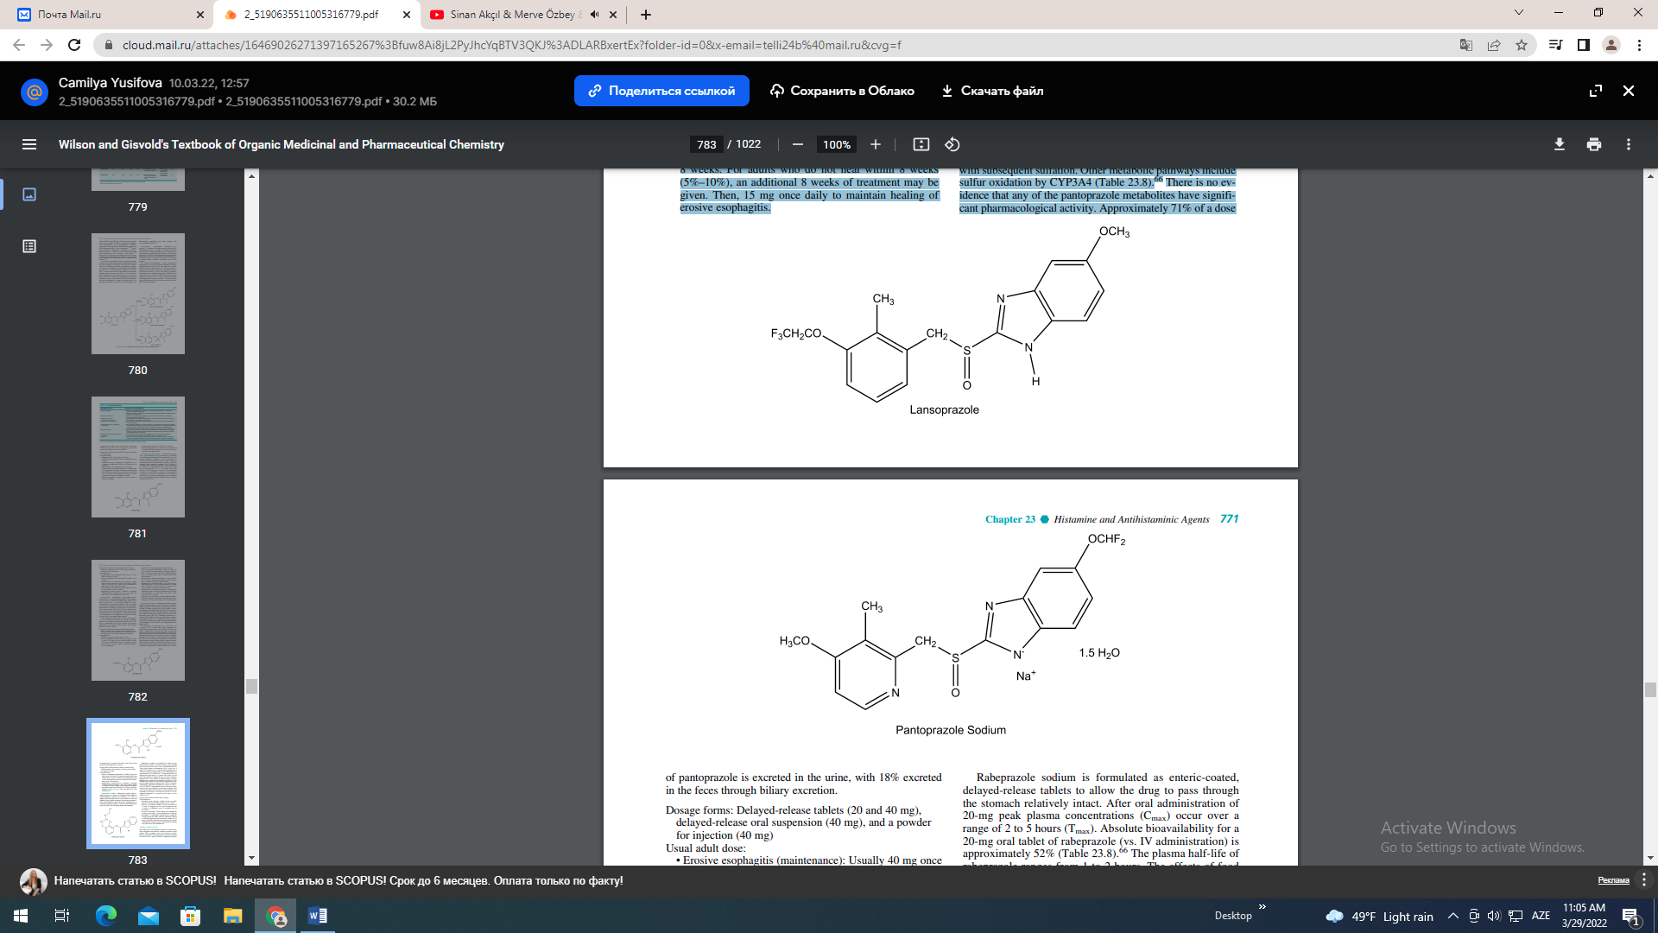
Dosage forms: Delayed-release tablets (20 and 40 mg), delayed-release oral suspension (40 mg), and a powder for injection (40 mg) Usual adult dose: • Erosive esophagitis (maintenance): Usually 40 mg once daily for up to 8 weeks. For those patients who have not healed after 8 weeks of treatment, an additional 8-week course of pantoprazole may be considered. The maintenance dose is 40 mg daily. • Pathological hypersecretory conditions, including Zollinger-Ellison syndrome: The usual starting dosage is 40 mg twice daily. Adjust dosage regimens to individual patient needs and continue for as long as clinically indicated. Doses of up to 240 mg daily have been administered. Rabeprazole Sodium. Rabeprazole sodium, 2[[[4-(3- methoxypropoxy)-3-methyl-2-pyridinyl]methyl]sulfinyl]- 1H-benzimidazole sodium salt (Aciphex), is a white to slightly yellowish white solid. It is very soluble in water and methanol, freely soluble in ethanol, chloroform, and ethyl acetate, and insoluble in ether and hexane. Rabeprazole is a weak base (pyridine N, pKa 4.53) and a weak acid (benzimidazole N-H, pKa 0.62), faciliting sodium salt formation.
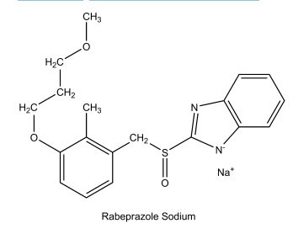
Rabeprazole sodium is formulated as enteric-coated, delayed-release tablets to allow the drug to pass through the stomach relatively intact. After oral administration of 20-mg peak plasma concentrations (Cmax) occur over a range of 2 to 5 hours (Tmax). Absolute bioavailability for a 20-mg oral tablet of rabeprazole (vs. IV administration) is approximately 52% (Table 23.8).66 The plasma half-life of rabeprazole ranges from 1 to 2 hours. The effects of food on the absorption of rabeprazole have not been evaluated. Rabeprazole is 96% bound to human plasma proteins. Rabeprazole is extensively metabolized in the liver. The thioether and sulfone are the primary metabolites measured in human plasma resulting from CYP3A oxidation. Additionally, desmethyl rabeprazole is formed via the action of CYP2C19. Approximately 90% of the drug is eliminated in the urine, primarily as thioether carboxylic acid and its glucuronide and mercapturic acid metabolites. The remainder of the dose is recovered in the feces. No unchanged rabeprazole is excreted in the urine or feces (Table 23.8).66 Dosage form: Delayed-release tablets (20 mg) Usual adult dose: • Duodenal ulcers (healing): Usually 20 mg once daily after the morning meal for a period of up to 4 weeks • Erosive or ulcerative GERD: 20 mg once daily for 4 weeks. If symptoms do not resolve completely after 4 weeks, an additional course of treatment may be considered. • H. pylori eradication: Triple therapy with rabeprazole (20 mg), amoxicillin (1 g), and clarithromycin (500 mg) • Treatment of pathological hypersecretory conditions: Usually 60 mg once daily, but doses should be adjusted to individual patient needs and should continue for as long as clinically indicated. Some patients may require divided doses. Dosages of up to 100 mg daily and 60 mg twice daily have been administered.
CHEMICAL COMPLEXATION The sulfate esters and sulfonate derivatives of polysaccharides and lignin form chemical complexes with the enzyme pepsin. These complexes have no proteolytic activity. Because polysulfates and polysulfonates are poorly absorbed from the GI tract, specific chemical complexation appears to be a desirable mechanism of pepsin inhibition.77 Unfortunately, these polymers are also potent anticoagulants. The properties of chemical complexation and anticoagulant action are separable by structural variation. In a comparison of selected sulfated saccharides of increasing number of monosaccharide units, from disaccharides through starch-derived polysaccharides of differing molecular size, three conclusions are supported by the data: (a) the anticoagulant activity of sulfated saccharide is positively related to molecular size; (b) anticoagulant activity is absent in the disaccharides; and (c) the inhibition of pepsin activity and the protection against experimentally induced ulceration depend on the degree of sulfation and not on molecular size.77 The readily available disaccharide sucrose has been used to develop a useful antiulcer agent, sucralfate. Sucralfate. Sucralfate, 3,4,5,6-tetra-(polyhydroxyaluminum)--D-glucopyranosyl sulfate-2,3,4,5-tetra-(polyhydroxyaluminum)--D-fructofuranoside sulfate (Carafate), is the aluminum hydroxide complex of the octasulfate ester of sucrose. It is practically insoluble in water and soluble in strong acids and bases. It has a pKa value between 0.43 and 1.19.
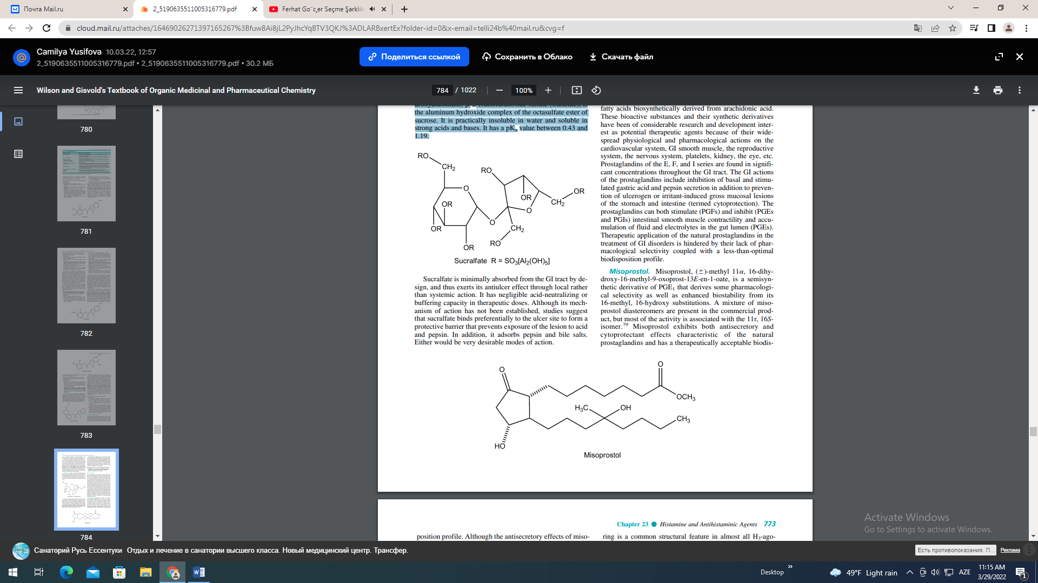
Sucralfate is minimally absorbed from the GI tract by design, and thus exerts its antiulcer effect through local rather than systemic action. It has negligible acid-neutralizing or buffering capacity in therapeutic doses. Although its mechanism of action has not been established, studies suggest that sucralfate binds preferentially to the ulcer site to form a protective barrier that prevents exposure of the lesion to acid and pepsin. In addition, it adsorbs pepsin and bile salts. Either would be very desirable modes of action. The simultaneous administration of sucralfate may reduce the bioavailability of certain agents (e.g., tetracycline, phenytoin, digoxin, or cimetidine).78 It further recommends restoration of bioavailability by separating administration of these agents from that of sucralfate by 2 hours. Presumably, sucralfate binds these agents in the GI tract.78 The most frequently reported adverse reaction to sucralfate is constipation (2.2%). Antacids may be prescribed as needed but should not be taken within 0.5 hour before or after sucralfate. Dosage forms: Tablets ( l g) and suspension (1 g/10 mL) Usual adult dose: 1 g (10 mL or 2 teaspoons of the oral suspension) 4 times a day on an empty stomach. Oral, 1 g 4 times a day on an empty stomach. Treatment should be continued for 4 to 8 weeks. PROSTAGLANDINS The prostaglandins are endogenous 20-carbon unsaturated fatty acids biosynthetically derived from arachidonic acid. These bioactive substances and their synthetic derivatives have been of considerable research and development interest as potential therapeutic agents because of their widespread physiological and pharmacological actions on the cardiovascular system, GI smooth muscle, the reproductive system, the nervous system, platelets, kidney, the eye, etc. Prostaglandins of the E, F, and I series are found in significant concentrations throughout the GI tract. The GI actions of the prostaglandins include inhibition of basal and stimulated gastric acid and pepsin secretion in addition to prevention of ulcerogen or irritant-induced gross mucosal lesions of the stomach and intestine (termed cytoprotection). The prostaglandins can both stimulate (PGFs) and inhibit (PGEs and PGIs) intestinal smooth muscle contractility and accumulation of fluid and electrolytes in the gut lumen (PGEs). Therapeutic application of the natural prostaglandins in the treatment of GI disorders is hindered by their lack of pharmacological selectivity coupled with a less-than-optimal biodisposition profile. Misoprostol. Misoprostol, ()-methyl 11, 16-dihydroxy-16-methyl-9-oxoprost-13E-en-1-oate, is a semisynthetic derivative of PGE1 that derives some pharmacological selectivity as well as enhanced biostability from its 16-methyl, 16-hydroxy substitutions. A mixture of misoprostol diastereomers are present in the commercial product, but most of the activity is associated with the 11r, 16Sisomer.79 Misoprostol exhibits both antisecretory and cytoprotectant effects characteristic of the natural prostaglandins and has a therapeutically acceptable biodis- position profile.

Although the antisecretory effects of misoprostol are thought to be related to its agonistic actions at parietal cell prostaglandin receptors, its cytoprotective actions are proposed to be related to increases in GI mucus and bicarbonate secretion, increases in mucosal blood flow, and/or prevention of back diffusion of acid into the gastric mucosa.80 Misoprostol is rapidly absorbed following oral administration and undergoes rapid deesterification to the pharmacologically active free acid with a terminal half-life of 20 to 40 minutes. Misoprostol is commonly used to prevent NSAID-induced gastric ulcers in patients at high risk of complications from a gastric ulcer, such as elderly patients and patients with a history of ulcer. Misoprostol has also been used in treating duodenal ulcers unresponsive to histamine H2-antagonists; the drug does not prevent duodenal ulcers, however, in patients taking NSAIDS. Misoprostol can cause miscarriage, often associated with potentially dangerous bleeding. Dosage form: 100- and 200-g tablets Usual adult dose: Oral, 200 mg 4 times a day with food
HISTAMINE H₃- AND H₄-RECEPTOR LIGANDS
As discussed earlier, H₃-receptors are presynaptic receptors that regulate the release of histamine (autoreceptors) and other neurotransmitters (heteroreceptor).10,17 The H3- heteroreceptors have been identified in CNS, stomach, lung and cardiac tissues where they appear to regulate neurotransmitter release from histaminergic, noradrenergic, dopaminergic, cholinergic, serotoninergic, and peptidergic neurons. Histaminergic nerves are located in the hippocampus and project into many brain regions where they regulate sleep, alertness, feeding behavior, and memory. Thus, H3-receptor antagonists have a potential therapeutic role in learning and memory impairment, attention-deficit hyperactivity disorder, obesity, and even epilepsy. Furthermore, studies of the regulation of inflammatory processes, gastroprotection, and cardiovascular function suggest several therapeutic possibilities for peripherally acting histamine H3-agonists.10 To date, no histamine H3-receptor ligands have been approved for marketing in the United States. Potent H3-agonists (Fig. 23.17) are obtained by simple modifications of the histamine molecule.81,82 The imidazole ring is a common structural feature in almost all H3-agonists. Methylation of the aminoethyl side chain of histamine favors H3 activity. Introduction of one or two methyl groups to give -methylhistamine and ,-dimethylhistamine yields potent H3-agonists that show little selectivity among the histamine receptors. The increased potency of -methylhistamine is ascribed almost completely to its R-enantiomer (H3/H1 ratio 17). The clinical use of R--methylhistamine is compromised by rapid catabolism by histamine-Nmethyltransferase. Azomethine derivatives of R--methylhistamine have been developed and shown to possess anti-inflammatory and antinociceptive properties. Other H3- agonists include the isothiourea derivative, imetit, a highly selective, full agonist that is more potent than R--methylhistamine. A third type of H3-agonist is immepip, which may be considered as a histamine analog with an elongated and cyclized side chain. Immepip is both a highly selective and potent H3-agonist.81,82 A large number of H3-antagonists have been described.83 In general, antagonist structures conform to the general representation shown in Figure 23.18. The heterocycle component of this general structure is most commonly a 4-monosubstituted imidazole or bioisosteric equivalent. Chains A and B can be of various structures and lengths, and there is also wide latitude in the structural requirements for the polar group. Halogenated phenyl, cycloalkyl, and heteroaryl structures are usually found for the lipophilic moiety. Thioperamide (Fig. 23.18) was the first potent H3-antagonist to be described. This agent enhances arousal and/or vigilant patterns in a dose-dependent fashion in animals, suggesting possible use of CNS-acting H3-antagonists in treating sleep disorders characterized by excessive daytime sleep, such as narcolepsy.83 Other H3 structures are shown in Figure 23.18, including the natural product verongamine, isolated from a sea sponge. As discussed earlier, the H4-receptor appears to be involved in the differentiation of hematopoietic cells (myeloblasts and promyelocytes) and to modulate immune function by modulating eosinophil calcium levels and chemotaxis. Several H3-agonists (R--methylhistamine, imetit) and antagonists (thioperamide) are also ligands for H4-receptors.84 Based on its physiological role in immune and inflammatory processes, H4-antagonists may have utility in various autoimmune (rheumatoid arthritis, asthma) and allergic disorders (allergic rhinitis, etc.).10 To date, no histamine H4-receptor ligands have been approved for marketing in the United States.
